**Biological Sciences: Evolution.**

**Phylogeny and microbiome of the New Zealand Psylloidea (Hemiptera: Sternorrhyncha) reveal insect-bacteria co-evolution and a new case of phylosymbiosis*.***

Francesco Martoni1,2,3,*, Simon Bulman4,5, Alexander Piper3, Andrew Pitman5,6, Gary Taylor7, Ian Dickie8 & Karen Armstrong1,2,5.

1. *Bio-Protection Research Centre, Lincoln University, Lincoln 7647, New Zealand.*
2. *Plant Biosecurity Cooperative Research Centre, University of Canberra, ACT 2617, Australia.*
3. *Agriculture Victoria Research Division, AgriBio Centre, 5 Ring Road, Bundoora VIC 3083, Australia.*
4. *The New Zealand Institute for Plant & Food Research Ltd, Lincoln 7608, New Zealand.*
5. *Better Border Biosecurity (B3), Lincoln 7608, New Zealand.*
6. *Andy’s new address*
7. *The University of Adelaide, Adelaide 5005, South Australia.*
8. *Canterbury University*
9. *\*. Corresponding author:* Francesco Martoni, *Agriculture Victoria Research Division, AgriBio Centre, 5 Ring Road, Bundoora VIC 3083, Australia. Email:* [francesco.martoni@agriculture.vic.gov.au](mailto:francesco.martoni@agriculture.vic.gov.au)

**Abstract**

Like all phloem- and sap-feeding insects, psyllids (Hemiptera: Psylloidea) have a rather limited diet and depend on symbiotic bacteria for the provision of fundamental aminoacids. A number of studies has focused on the vertically transmitted primary symbiont, *Candidatus* Carsonella rudii, and a number of both vertically and horizontally transmitted secondary symbionts to determine their co-evolutionary relationships with psyllids. At the same time, the insect-bacteria relationships appear to have a major role in their host plant association, as in the case of aphids that can feed on new host plant when inoculated with a different symbiont. In the case of psyllids - insects with strong species-specific host plant associations - we hypothesised this assocaitive pattern could have a major role in their microbiome composition, either based on their phylogenetic diversity (co-evolution with the insect) or on their host plant association (co-evolution with the plant). In order to disentangle the major factors influencing psyllids’ microbiome composition, a metabarcoding analysis of the bacterial 16S gene was performed on a group of New Zealand psyllids and tested for correlation with a multi-marker phylogenetic study of the insects, their hostplant and their geographical distribution. We suggest that today’s New Zealand psyllid fauna originated from at least six ancestral lineages/arrivals, confirming monophyly of the New Zealand genera *Ctenarytaina* and *Psylla* and demonstrating that the present radiation of the New Zealand *Trioza* species and their association with endemic host plantsis the result of a number of host switches. The microbiome of the New Zealand psyllids species appeared to be strongly associated with the hosts’ phylogenetic relationships, highlighting a new case of phylosymbiosis. Furthermore, the results we obtained suggest that such insect-bacteria relationship is not driven by primary and secondary symbionts only, but by the whole microbiome. This suggests there are more symbiotic bacteria that have co-evolved with psyllids than previously thought.

**Significance Statement**

Bacteria living inside certain insects, such as psyllids, may provide advantages to their hosts, including provision of food and increased adaptability to environmental conditions. The same bacteria species can be found in the same psyllid species even when these live in different places, suggesting that psyllids and bacteria have co-evolved together for a long time, generating a strong bond between species. This co-evolution resulted in each insect species hosting a bacterial community almost as distinct as a finger print. This phenomenon, defined as phylosymbiosis, means that bacterial diversity is connected to the relationships between psyllid species. Here we confirmed that such relationship is not limited to only a few species of bacterial symbiont within each psyllids species, but to the entirety of the microbiome composition. This will improve our understanding of how bacteria and insects have co-evolved through time and how they have influenced each other in the process.

1. **Introduction**

The association between phloem feeding hemipterans insects, such as aphids and psyllids, and their host plant is partially dependant on bacterial endosymbionts, which provide nutrients to the insects (Douglas 2016). Research suggests that this symbiosis is a major driver of insect diversification, which is a first step towards adaptive radiation (Vavre and Kremer 2014). Variation in the microbiome has been linked to insect phenotypic traits associated with diversification and speciation (Hosokawa *et al.* 2007), while a rapid adaptation of some insects to a new host plant has been linked to modifications of the microbiome (Chu *et al*. 2013). These studies have led to the hypothesis that the switch by insects to novel host plants may be symbiont-mediated (Tsuchida *et al.* 2011, Frago *et al.* 2012). For example, S-symbionts in aphids were proposed to facilitate or restrict the use of certain host plants (Tsuchida *et al.* 2011, Hansen and Moran 2014).

Identifying drivers of microbiome composition can lead to understand the exact mechanisms used by insects to feed on multiple plants or switch to different host plants (e.g. Chu *et al.* 2013). In the case of economically important plants, if the microbiome composition of agricultural pests enables host plant switching, it consequently contributes to make the insect more invasive and dangerous to agriculture (Bennett 2013). Hence, it is important to understand possible patterns in the microbiome composition that can act as an adaptive trait allowing species to survive and proliferate in new habitats (Chu *et al.* 2013).

One of these patterns in the microbiome composition of animal species is known as phylosymbiosis (Brucker and Bordenstein 2012, Brooks *et al.* 2016): “a significant association between host phylogenetic relationships and host-associated microbial community relationships” (Lim and Bordenstein 2019). This definition can be extended into “an eco-evolutionary pattern where evolutionary changes in the host are associated with ecological changes in its microbiome” (Sanders *et al.* 2014; Brooks *et al.* 2016). Determining the presence of a phylosymbiotic pattern within the microbiome of closely related species can highlight the presence of specific groups of bacteria providing their hosts with adaptive traits (Lim & Bordenstein 2019). Furthermore, phylosymbiosis defines a quantifiable link between the host evolutionary relationships and the microbiome diversity and composition, therefore providing a testable hypothesis as to the point in evolutionary time when a certain lineage acquired a trait (Lim & Bordenstein 2019). For example, a similar microbiome composition for two closely related species might suggest that they could both feed on the same plants, even if such plants are not currently part of both species’ diets. Such information could then be used to estimate how long it could take to a closely related species to develop the same trait, if exposed to the same bacterial lineages; or it could be hypothesised that one species might become a pest if introduced in the habitat of the other closely related species. Therefore, the presence and degree of phylosymbiosis across an insect group could be implemented in ecological modelling analysis used to predict invasive species movements or likeliness of pathogens-vectoring (i.e. Syfert *et al.* 2017). However, despite having been recorded in a number of organisms, including rodents (Kohl *et al.* 2017), corals (Pollock *et al.* 2018), and insects (Colman *et al.* 2012; Minard *et al.* 2017), phylosymbiosis has not been recorded within the order Hemiptera, which includes a wide number of agricultural pests such as aphids and psyllids.

Psyllids, also known as jumping plant-lice (Hemiptera), belong to the superfamily Psylloidea and constitute a small group (~3800 described species) of highly specialized plant sap-feeders within the suborder Sternorrhyncha. Their life cycle includes five nymphal (immature) stages before the adult one. The plant on which the nymphs can complete their life cycles and become adults are considered host plants (Burckhardt *et al.* 2014). Since the number of host plants for each psyllid species is usually restricted to one or a few closely related plant species (Brown & Hodkinson 1988), psyllids are considered highly host specific. Furthermore, closely related psyllid species tend to develop on closely related plant species (Burckhardt & Basset 2000; Percy *et al.* 2004). For these reasons, psyllids can be considered a useful model group to study insect-plant relationships (e.g., Hollis 1987; Hollis & Broomfield 1989; Percy *et al.* 2004; Hodkinson 2009; Ouvrard *et al.* 2015). Despite this generally strong psyllid-host plant specificity, some genera appear to show a different trend. This is the case of *Trioza*, which appears to have a very high number of host plants worldwide (Ouvrard *et al.* 2015). However, the lack of a complete phylogenetic study of *Trioza* raised concerns on its taxonomical robustness, especially considering it has been deemed a “catch-all genus” (Ouvrard *et al.* 2015), suggesting the wide host plant association may be inflated by the presence of multiple genera erroneously classified under *Trioza* (Burckhardt & Ouvrard 2012).

Host plant specificity (Brown and Hodkinson 1988) has also been associated with bacterial symbionts of psyllids (Hansen and Moran 2014). However, the majority of psyllid-associated bacteria studies have been driven by the need to understand insect-pathogen pairings of economic concern (e.g., Saha *et al.* 2012). This channelling of research focus has limited attention on the microbiome composition and evolution across a broader range of psyllids. Most studies of the psyllid microbiome have focused on the primary symbiont “*Candidatus* Carsonella rudii”. All have reported phylogenetic congruence between *Ca.* C. rudii and its psyllid hosts as evidence for strict co-speciation (Thao *et al.* 2000a; Thao *et al.* 2001; Sloan and Moran 2012; Hall *et al.* 2016). Due to their role in the synthesis of essential amino acids, a subset of S-endosymbionts have also established long-term, stable associations with psyllids (Sloan and Moran 2012). Partial vertical transmission is seen in this group of symbionts, but incongruence between the phylogenies of S-endosymbionts and hosts appears to indicate ongoing horizontal transmission of S-symbionts between psyllid species (Thao *et al.* 2000b). The microbiome analysis of the Australian psyllid genus *Cardiaspina* confirmed both vertical and horizontal transmission of S-symbionts(Hall *et al.* 2016).

Understanding the transmission of symbiotic bacteria in psyllids has been partly limited by the lack of a robust phylogenetic framework for a suitable subset of taxa. However, recent mitochondrial and nuclear genomic analyses have provided a phylogenetic backbone for the Psylloidea worldwide (Percy *et al.* 2018; Cho *et al.* 2019). Molecular studies of the Asia-Pacific Psylloidea, on the other hand, have focussed more on COI DNA barcoding to understand specific aspects of biodiversity (Taylor *et al.* 2016; Percy 2017; Martoni *et al.* 2018).

New Zealand is home to 74 described species of psyllids and almost 50 undescribed taxa, belonging to 24 genera and six families (Dale 1985; Macfarlane et al. 2010; Martoni et al. 2018; Martoni & Armstrong 2019a,b). The New Zealand psyllid fauna offers an example of diversity across the superfamily Psylloidea, including ancient lineages and recent arrivals. Such diversity includes both native and adventive species (Martoni *et al.* 2016), with some species of economic importance, such as *Arytainilla spartiophila*, a bio-control agent of the Scotch Broom, *Cytisus scoparius* (Syrett *et al.* 2007), and the tomato/potato psyllid (TPP), *Bactericera cockerelli* Šulc, a significant pest (Vereijssen *et al.* 2018). The vast majority of the New Zealand endemic species belong to three main genera: *Ctenarytaina, Psylla* and *Trioza* (Martoni *et al.* 2018), withthe latter alone including more than 50 species across a wide range of host plant families and genera. Indeed, the three psyllid genera show very different host plant association patterns, with *Psylla* (7 taxa) and almost all the species of *Ctenarytaina* (14/15) each being associated with a single plant family. On the other hand, the genus *Trioza* appears to be associated with more than 12 plant families and over 20 genera.

The high variation within the endemic taxa in the New Zealand psyllid fauna provides an opportunity to examine microbiome structure in the context of insect-bacteria-host plant evolution (e.g. Ferris and Klyver 1932, Tuthill 1952; Dale 1985). Indeed, New Zealand’s landmass has undergone a series of geological events since separating from the Gondwanan super continent (80 MYA), including partial sinking and mountain uplifts that have had strong impact on its fauna. Consequently, the current insect fauna may derive from ancient lineages present before separation, but it might as well have dispersed to New Zealand in more recent times, especially on westward winds (e.g. Greenslade *et al.* 2001; Goldberg *et al.* 2008; Buckley *et al.* 2015). Studying this psyllid-plant-bacteria associations within the New Zealand fauna can therefore answer a number of evolutionary and ecological questions.

For example, obtaining a phylogenetic structure for the analysis of the microbiome of these psyllids would also answer questions on the systematics and evolution of this group of insects. Indeed, the taxonomic position of the New Zealand genera *Atmetocranium* and *Anomalopsylla,* has been debated for more than 70 years (Ferris and Klyver 1932; Tuthill 1952; Heslop-Harrison 1960; Bekker-Migdisova 1973; Dale 1985; Burckhardt and Ouvrard 2012). At present, *Atmetocranium* is provisionally assigned to the family Calophyidae, together with South American species (Burckhardt and Ouvrard 2012), while *Anomalopsylla* is currently assigned to the subfamily Rhinocolinae (Aphalaridae) (Burckhardt & Ouvrard 2012).

To understand the relationships between New Zealand psyllids and their microbiome, here we generated a phylogenetic structure of this group. We then assessed the bacterial microbiomes diversity using high throughput 16S amplicon metabarcoding. The aims of this work were to establish: i) the number of ancestral arrival events that have led to the current day native psyllid fauna and ii) what evolutionary processes have led to the current psyllid-plant host relationships in New Zealand. Ultimately, these points would allow us to understand what the main driver of psyllids’ microbiome composition is. In particular we aimed to iii) verify that one of the factors influencing the microbiome composition of the New Zealand psyllids could be the host evolutionary history, as opposed to a co-evolution with the host plants of the insects.

**Materials and methods**

* 1. ***Psyllid DNA extraction, amplification and sequencing.***

DNA, from individual adult psyllids, was from (Martoni *et al.* 2018) or a selection of new samples from Australia and United States of America (Table SM1). PCR protocols essentially followed Martoni *et al.* (2018). For the ribosomal 18S, a 544-bp PCR product was amplified from 179 specimens using the primers 18S_F (CTGGTTGATCCTGCCAGAGT; Ouvrard *et al.* 2000) and 18S_Rmod, (ACCAGACTTGCCCTCCAAT; modified in this study from Ouvrard *et al.* 2000). Thermal cycling conditions were an initial denaturation at 94°C for 5 min, followed by 40 cycles of denaturation at 94°C for 30 s, annealing at 50°C for 30 s and extension at 72°C for 1 min, followed by a final extension of 7 min. For COI, PCRs were performed on 16 new individual psyllids including specimens of *Blastopsylla, Cryptoneossa* and two species of Triozidsfrom Australia (*Trioza tricornuta* and *Acanthocasuarina acutivalvis*) (Table SM1). All amplicons were sequenced directly using the Sanger method (Bio-Protection Research Centre, Lincoln University, New Zealand) with the PCR amplification primers. Twenty partial Elongation Factor-1α sequences (240 bp) were from (Martoni *et al.* 2017). A new EF1 α sequence was isolated here from *Atmetocranium myersi* (Acc. Number MH556913).

* 1. ***DNA sequence variation and phylogenetic analysis***

In total there were 665 psyllid DNA sequences used (plus three aphid sequences used as the outgroup), paired by specimen for each locus (Table SM1). This included sequences from all 90 psyllid taxa identified as present in New Zealand (Martoni *et al*. 2018) with at least two specimens from each species used where possible, plus ten species from Australia, Europe and USA. In addition, 16 sequences for the same COI and 18S gene regions were obtained from GenBank from six psyllid taxa, which were two species of *Trioza* (*T. remora and T. urticae*), two species of *Psylla* (*P. alni and P. buxi*), and the species *Rhinocola aceris* and *Heterospylla texana*. The pea aphid, *Acyrthosiphon pisum*, was used as an outgroup (Table SM1). For each gene, DNA sequences were manually quality-checked, and alignments performed using MEGA version X (Kumar *et al.* 2018). Phylogenetic and molecular evolutionary analyses were conducted using MEGA version X (Kumar *et al.* 2018). Maximum likelihood [ML] phylogenetic trees were then constructed using the Kimura-2-parameter [K2P] model (Kimura 1980) with a bootstrap of 10,000 replicates (Figures SM1 and SM2).

The best substitution model for each gene alignment was calculated in MEGA X using the Bayesian information criterion (BIC, Schwarz 1978). The General Time-Reversible (GTR) model (Tavaré 1986) was used for COI, the Tamura and Nei (TN93, Tamura and Nei 1993) model for 18S and the Hasegawa, Kishino, Yano (HKY) model (Hasegawa *et al.* 1985) for EF-1α. A three-gene species tree was developed using the package Starbeast (*BEAST, Heled and Drummond 2010) in BEAST v2.5.1, with the Markov Chain Monte Carlo (MCMC) method (Drummond *et al.* 2012; Bouckaert *et al.* 2014; Bouckaert *et al.* 2018) and multiple chains of 1 billion replicates each. Each model was selected together with a gamma distribution with a rate of 4. The mitochondrial gene COI was set to a 0.5 ploidy compared to the 2.0 for both 18S and EF-1α, as suggested for multi-gene analyses (Drummond & Bouckaert 2015). The software Tracer v1.7 (Rambaut *et al.* 2018) was used for visualization and diagnostics of the MCMC output. This confirmed that the Bayesian analysis had reached convergence and the resulting estimated sample size (ESS) was >>200 (508). LogCombiner was used to subsample the number of trees from 500000 to 100000. TreeAnnotator (Drummond *et al.* 2012; Bouckaert *et al.* 2014) was used to summarize the information in a single tree and to set a 10% burn-in based on the information visualized with Tracer. The resulting species tree was drawn using FigTree v1.4.3 (Rambaut 2016).

* 1. ***Microbiome sequencing***

The V3 and V4 regions of the bacterial 16S ribosomal RNA gene were amplified from a total of 220 whole insect specimens (Table S1), encompassing 65 species across 178 populations collected both in New Zealand and in Australia. DNA extractions, amplification and purification were performed in a Physical Containment [PC2] facility in order to minimize the risk of environmental contamination. Sixteen of the 200 individuals were sequenced twice (as technical replicates), in order to confirm the consistency of the results (Table 1). Amplification was conducted using 16S_F and 16S_R primers (Klindworth *et al.* 2013), modified with Illumina adapters as per the Illumina 16S Metagenomic protocol 15044223 Rev. B (available at https://support.illumina.com/downloads/16s_metagenomic_sequencing_library_preparation.html). PCR amplification was performed using an initial denaturation at 95°C for 3 min, followed by 25 cycles of 95°C denaturation for 30 s, 55°C annealing for 30 s and 72°C elongation for 30 s. A final 72°C elongation was performed for 5 min. Amplicons were verified on 1% agarose gel and checked for absence of visible bands in control samples, then purified using the Agencourt® AMPure® XP kit (Beckman Coulter, Brea, California, United States). The concentrations of PCR products were measured using a NanoDrop 1000 (Thermo Fisher Scientific, Waltham, Massachusetts, United States) and samples at concentrations between 10 ng/μL and 50 ng/μL were sequenced on an Illumina MiSeq platform using 2x300bp reads at New Zealand Genomics Limited (NZGL).

* 1. **Microbiome bioinformatics**

Demultiplexed MiSeq reads (NCBI SRA acc no: xxxxxxx) were trimmed of PCR primers and sequencing adapters using BBDuK in BBTools v38.01 (Bushnell 2017). All reads containing ambiguous ‘N’ bases were removed, and sequence quality profiles were used to filter reads with more than two expected errors in the forward read, or 3 in the reverse read. Due to the quality crash at the end of reverse reads typical of 2x300bp Illumina sequencing, all reverse reads further truncated to 200bp to minimize the number of reads violating the error filter. Quality trimmed sequences were then analysed using DADA2 v1.9.3 (Callahan *et al.* 2018). As error rates can vary between flow cells and libraries, the DADA2 error model was determined separately for each MiSeq lane using the “pseudo-pooling” mode for increased sensitivity to rare variants. Following denoising, the inferred amplicon sequence variants (ASVs) from each MiSeq lane were merged into a single table, which was further filtered to remove chimeras and ASVs outside the expected amplification length of 400:435bp. Heirarchial taxonomy was assigned to the 3171 ASVs to the lowest rank possible with a minimum bootstrap support of 60% using the IDTAXA algorithm (Murali *et al.* 2018) and the Silva v138 database (Quast *et al.* 2013). This was followed by extra species level assignment using exact matching between the query and reference sequences, which has previously been shown to be the most robust method for assigning species level taxonomy to short 16S reads (Edgar 2018). Following taxonomic assignment, ASV’s were further curated using co-occurance patterns with LULU (Frøslev *et al.* 2017), all samples with below 1000 total reads remaining, and all taxa that were classified as chloroplast, mitochondrial, or non-bacterial were removed, and technical replicates were merged. The remaining 726 curated ASVs were then aligned alongside 3413 nearest neighbour sequences obtained from the SILVA 138 database using the SINA algorithm (Pruesse *et al.* 2012). A ML bacterial phylogenetic tree was generated from the entire alignment using FastTree (Price *et al.* 2009) with the General Time-Reversible (GTR) model (Tavaré 1986) and gamma model of rate heterogeneity across sites. This tree was then time scaled and made ultrametric via congruification (Eastman *et al.* 2013) with the time dated SILVA 16s 97% similarity reference tree of Louca et al (Louca *et al.* 2018) using 839 shared tips (nearest neighbour sequences obtained from the SILVA database) and the geiger R package (Pennel *et al.* 2014).

* 1. ***Statistical Analysis***

*Alpha diversity*

The observed richness of ASV’s and Shannon index (less sensitive to rare OTUs) were calculated using the R package phyloseq (McMurdie & Holmes 2013), and phylogenetic diversity (sums the total branch length of the resulting bacterial phylogeny) (Faith 1992) was calculated with the picante R package (Kembel *et al.* 2010). ANOVA was used to test if differences between alpha diversity statistics could be explained by the psyllid taxa. To test if differences in microbiome alpha diversity between psyllids was related to phylogeny, Morans I statistic of autocorrelation(Moran 1950), as well as Pagel's λ (Pagel 1999) and Bloombergs K (Blomberg *et al.* 2003) which use a Brownian motion model of evolution were calculated using the phylosignal R package (Keck *et al.* 2016). As phylogenetic signal can be scale dependent and vary among clades, we further calculated local signals of autocorrelation within the phylogeny using the Local Morans I (Anselin 1995). All tests of alpha diversity relationships were calculated with the original data as well as data rarefied to the sequencing depth of the lowest sample (1177 reads) to ensure patterns could were not explained by differences in sequencing depths between samples.

*Beta diversity*

To assess the differences in community composition between samples, the compositionally aware Aitchison distance (Aitchinson *et al.* 2000; Gloor *et al.* 2017) was calculated, with zeroes imputed using Bayesian-multiplicative replacement with the zCompositions R package (Palarea-Albaladejo & Martín-Fernández 2015). To test the significance of categorical variables for predicting microbiome beta diversity, Permutational Multivariate Analysis Of Variance Using Distance Matrices (adonis) and PERMDISP tests of homogeneity of variance were performed with 999 permutations using the vegan R package (Oksanen *et al.* 2019). During the specimen collection a number of psyllid specimens of different species were collected from the same individual hostplant, and to further evaluate the differential influence of psyllid species and hostplant, the pairwise beta diversity between these specimens was compared using pairwise adonis tests.

*Phylosymbiosis*

To identify patterns of phylosymbiosis, bacterial beta diversity was compared to psyllid phylogenetic distance, plant phylogenetic distance and geographic distance using Mantel tests (Mantel 1967) of Pearsons correlation between microbiota and individual matrix as well as Partial Mantel tests controlling for all other matrices using the ecodist R package (Goslee & Urban 2007) . The psyllid pairwise phylogenetic distance was calculated from the branch lengths of the multigene phylogenetic tree generated in this study using the cophenetic.phylo function in the ape R package (Paradis & Schliep 2018), and made Euclidean by taking the element wise square root (deVienne *et al.* 2011). To assemble a pairwise distance matrix of hostplant phylogeny, psyllid host plant observations were obtained from the literature (Burckhardt *et al.* 2014) (e.g., Dale 1985, Ferris and Klyver 1932, Tuthill 1952) or from direct observations on the host plant that the psyllids were located on (Martoni *et al.* 2018). These plant species observations were hen used to retrieve a phylogenetic tree using phylomatic (Webb & Donoghue 2005) as implemented in the brranching R package (Chamberlain 2019) and pairwise distances generated from branch lengths as above. To obtain a geographic distance matrix, pairwise Great Circle distances were calculated between latitude and longitude coordinates from collection locations for each specimen used in the study using the sp R package (Bivand *et al.* 2013). Significance of Mantel and partial Mantel tests was assessed against 999 permutations of the rows and columns of each dissimilarity matrix. 95% confidence intervals for the Mantel correlations were obtained using 1000 bootstrap replicates. To further disentangle the phylogenetic scale of correlations between microbiome beta diversity and cofactors, beta diversity through time analysis (BDTT) (Groussin *et al.* 2017) was used to sample the bacterial phylogenetic tree in 10Mya time intervals backwards in evolutionary time using the tree agglomeration functions of castor (Louca & Doebeli 2017) and speedyseq (McLaren 2020). Partial Mantel tests were conducted on the ASV tables at each time slice in order to differentiate patterns arising from recent co-diversification from those due to more ancient bacterial evolution. To ensure robustness to the impacts of index switching, all beta diversity, phylosymbiosis and cophylogeny metrics were conducted with and without a 0.1% relative abundance filter.

Co-phylogeny

Beta diversity through time analysis suggested that patterns of phylosymbiosis was driven by more recent co-diversification. In addition to the well-known association with their primary symbiont *Candidatus* Carsonella rudii, psyllid species can be associated various secondary symbionts with differing rates of vertical inheritance. To identify these groups without making apriori assumptions of the taxonomy of potential secondary symbionts, phylogenetic congruence between the psyllid and the microbial phylogeny was investigated at the scale of the entire community of co-occurring species using the Procrustean Approach to Co-phylogeny (PACo) algorithms (Balbuena *et al.* 2013; Hutchinson *et al.* 2017). Parafit focuses on testing random associations between the host and symbiont taxa, while PACo explicitly tests the dependence of the symbiont phylogeny upon the host phylogeny. For application of PACo the symmetric Procrustes statistic was used, and significance was assessed using 100,000 permutations using the ‘quasiswap’ method which makes no assumptions on the symbionts tracking host evolution or vice versa. Given that microbial communities are generally labile assemblages with a large stochastic component (Zhou & Ning 2017), it is to be expected that certain interactions (such as symbiosis) are more consistent with a hypothesis of phylogenetic congruence than others. To estimate the importance of specific host-microbe interactions towards the overall phylogenetic congruence, for both Parafit and PACo a jackknife approach was used where individual Interactions were iteratively removed and the individual interaction strength calculated as the difference between global fit and the fit without an interaction. For Parafit, the more conservative ParaFitLink 1 function was used, under which individual associations were considered significant if the one-tailed probabilities (P-values) of the data under the null hypothesis were below an alpha of 0.05. While for PACo, Individual interactions were considered as significantly supporting cophylogenetic congruence if their upper 95% confidence interval was below the mean of all squared jackknifed residuals (Balbuena *et al.* 2013). To compare the entire microbiome to just the symbionts, ParaFit and PACo were fit separately to just the ASVs assigned to the genus Carsonella using the above parameters but filtering to just the top carsonella ASV per specimen to minimise potential impacts of index switching. In order to contrast the co-diversification of psyllids and microbes with the hostplants, both algorithms were further fit to the psyllid and hostplant phylogenies using the same parameters above. Finally, the psyllid phylogeny was pruned to just taxa within the genus Trioza, and the ParaFit and PACo fits above were reassessed using just the microbials ASVs and hostplants associated with the Trioza. To visualise the interaction strengths between the above phylogenies, the tree rotation functions of phytools (Revell 2012) were used to rotate each node of the compared phylogenies by their best fit, and tanglegrams were plotted using ggplot2 (Wickham 2016) and the ggtree extension (Yu *et al.* 2017; 2018). All statistical analyses above were conducted within the R3.6 statistical programming environment (R Core Team 2019) using tidyverse packages (Wickham *et al.* 2019).

**Results**

* 1. ***Evolutionary relationships amongst the New Zealand psyllid fauna***

The 460 psyllid COI sequences aligned here had 211 parsimony informative sites and showed high intra-generic nucleotide variation resulting in more than 200 haplotypes (Figure 1a). Accordingly, the COI ML tree (Figure SM1) could successfully separate all the taxa included here, as also previously reported for the original subset of sequences (Martoni *et al.* 2018). However, deeper nodes at family and genus level were not well supported. The 184 18S sequences (from 100 taxa) had 49 parsimony informative sites and a total of 57 haplotypes after excluding five regions within the sequences that had insertions/deletions (Figure 1b). Therefore, while the 18S haplotype network (Figure 1b) could generally separate the different genera (with three exceptions, Figure 1), it often failed to separate different species, especially within the genera *Acizzia, Trioza* and *Ctenarytaina* (Figure 1b). Overall, the 18S ML tree showed a stronger bootstrap value for the nodes separating genera, compared to the COI ML tree that instead had stronger support for the nodes separating species (Figures SM1 and SM2).

The species tree inferred using the three alignments showed a structure with generally high posterior probability values at species, genus and family level (Figure 2). Here, the New Zealand native psyllids (determined as those hosted by New Zealand native plants; Martoni *et al.* 2016) fell into six lineages with the major clades represented by the genera *Ctenarytaina* (Aphalaridae)*, Psylla* (Psyllidae) and *Trioza* (two clades) (Triozidae), plus one lineage each for the genera *Atmetocranium* (Calophyidae) and *Anomalopsylla* (Aphalaridae). The species adventive to New Zealand (all the other genera, Table 1) were divided into a total of six families.

Within the subfamily Spondyliaspidinae (Aphalaridae), the New Zealand ***Ctenarytaina***formed a monophyletic clade, closely related to five Australian *Ctenarytaina* which formed another monophyletic clade diverged by 2.1% (Figure 2). Other genera within the same subfamily were more distant to New Zealand *Ctenarytaina*, ranging between the 4.1% of *Glycaspis* and the 4.75% of *Creiis* and *Cardiaspina* (Figure 2). Within the New Zealand *Ctenarytaina,* three taxa from *Fuchsia* *excorticate* (Onagraceae) were the earliest branching group. The second clade contained *Ctenarytaina* sp. A hosted by *Olearia* (Asteraceae) and the taxa from Myrtaceae. Separated from the other genera of the Aphalaridae, the genus ***Anomalopsylla*** clusters together with European species *Rhinocola aceris.* The New Zealand ***Psylla*** formed a monophyletic group. This includes two described species and five undescribed taxa diverging more than 3.2% (3.23%) from the closest *Psylla* species from Europe. The subfamily Psyllinae forms a monophyletic group including the New Zealand *Psylla* and other non-New Zealand species, comprising the adventive genera *Baeopelma* and *Arytainilla*, and European *Psylla buxi* and *P. alni*, but also the North American *Heteropsylla texana* (Ciriacreminae). The Psyllinae are well separated by a 1.9% divergence from the other monophyletic Psyllidae subfamily, the Acizzinae, represented in New Zealand by the Australian genus *Acizzia.* Within the Triozidae, all but one of the 31 native New Zealand *Trioza* species cluster into a single monophyletic clade (Figure 2). The closest non-New Zealand relative was the European *T. urticae*, although the bootstrap support for this relationship was low. The native *T. curta* diverged from the other New Zealand *Trioza* by 4%, demonstrating a separate ancestral introduction. *Trioza curta* formed a monophyletic association with *T. adventicia,* an adventive species from Australia that is hosted by another Myrtaceae species, *Syzygium* *smithii* (Percy 2017; Martoni 2017). The Australian triozids formed a monophyletic clade (including New Zealand’s *T. curta*) but with very weak affinities to one another. Beside the New Zealand species of the genus *Trioza,* the family Triozidae included the adventive species of the genera *Acanthocasuarina, Bactericera, Trioza* (from Australia and Europe)*, Casuarinicola* and an Australian triozid species collected from the host plant *Casuarina*. *Trioza* species not native to New Zealand included two spp. from Europe (*T. urticae* and *T. remota*) and one from Australia (*T. tricornuta*)*.* With the European *T. urticae* branching at the base of the major New Zealand group (including all but two species) while the New Zealand taxa *T. curta* clustered with *T. adventicia* and the rest of the Triozidae.

**Table 1: Psyllid taxa analysed** divided by families, subfamilies and genera, with number of species and individuals samples. The subfamily Atmetocraniinae (in red) is only tentatively assigned here to none of the current families. For each psyllid genus, the genes used in the analysis are marked with a tick (**✓).** Details on the psyllid species and their host plants are reported in Table SM1.

|  |  |  |  |  |  |  |  |
| --- | --- | --- | --- | --- | --- | --- | --- |
| **Family** | **Subfamily** | **Genus** | **Species** | **Samples** | **COI** | **18S** | **EF-1α** |
| Aphalaridae | Rhinocolinae | *Anomalopsylla* | 2 | 7 | **✓** | **✓** | **✓** |
|  |  | *Rhinocola* | 1 | 1 | **✓** | **✓** |  |
|  | Spondyliaspidinae | *Anoeconeossa* | 1 | 3 | **✓** | **✓** | **✓** |
|  |  | *Blastopsylla* | 1 | 6 | **✓** | **✓** | **✓** |
|  |  | *Cardiaspina* | 1 | 3 | **✓** | **✓** | **✓** |
|  |  | *Creiis* | 1 | 1 | **✓** | **✓** | **✓** |
|  |  | *Cryptoneossa* | 1 | 10 | **✓** | **✓** | **✓** |
|  |  | *Ctenarytaina* | 20 | 132 | **✓** | **✓** | **✓** |
|  |  | *Eucalyptolyma* | 1 | 2 | **✓** | **✓** | **✓** |
|  |  | *Glycaspis* | 1 | 2 | **✓** | **✓** | **✓** |
|  | Atmetocraniinae | *Atmetocranium* | 1 | 2 |  | **✓** | **✓** |
| Calophyidae | Calophyinae | *Calophya* | 1 | 4 | **✓** | **✓** |  |
| Liviidae | Euphyllurinae | *Psyllopsis* | 2 | 7 | **✓** | **✓** | **✓** |
|  |  | *Diaphorina* | 1 | 2 | **✓** | **✓** | **✓** |
| Homotomidae | Macrohomotominae | *Mycopsylla* | 1 | 5 | **✓** | **✓** | **✓** |
| Psyllidae | Acizzinae | *Acizzia* | 12 | 84 | **✓** | **✓** | **✓** |
|  | Psyllinae | *Arytainilla* | 1 | 4 | **✓** | **✓** |  |
|  |  | *Baeopelma* | 1 | 2 | **✓** | **✓** | **✓** |
|  |  | *Psylla* | 9 | 39 | **✓** | **✓** |  |
|  | Ciriacreminae | *Heteropsylla* | 1 | 1 | **✓** | **✓** |  |
| *Triozidae* |  | *Bactericera* | 2 | 7 | **✓** | **✓** | **✓** |
|  |  | Triozid sp. | 1 | 3 | **✓** | **✓** |  |
|  |  | *Casuarinicola* | 1 | 3 | **✓** | **✓** | **✓** |
|  |  | *Trioza* | 35 | 130 | **✓** | **✓** |  |
|  |  | *Acanthocasuarina* | 1 | 1 | **✓** | **✓** |  |

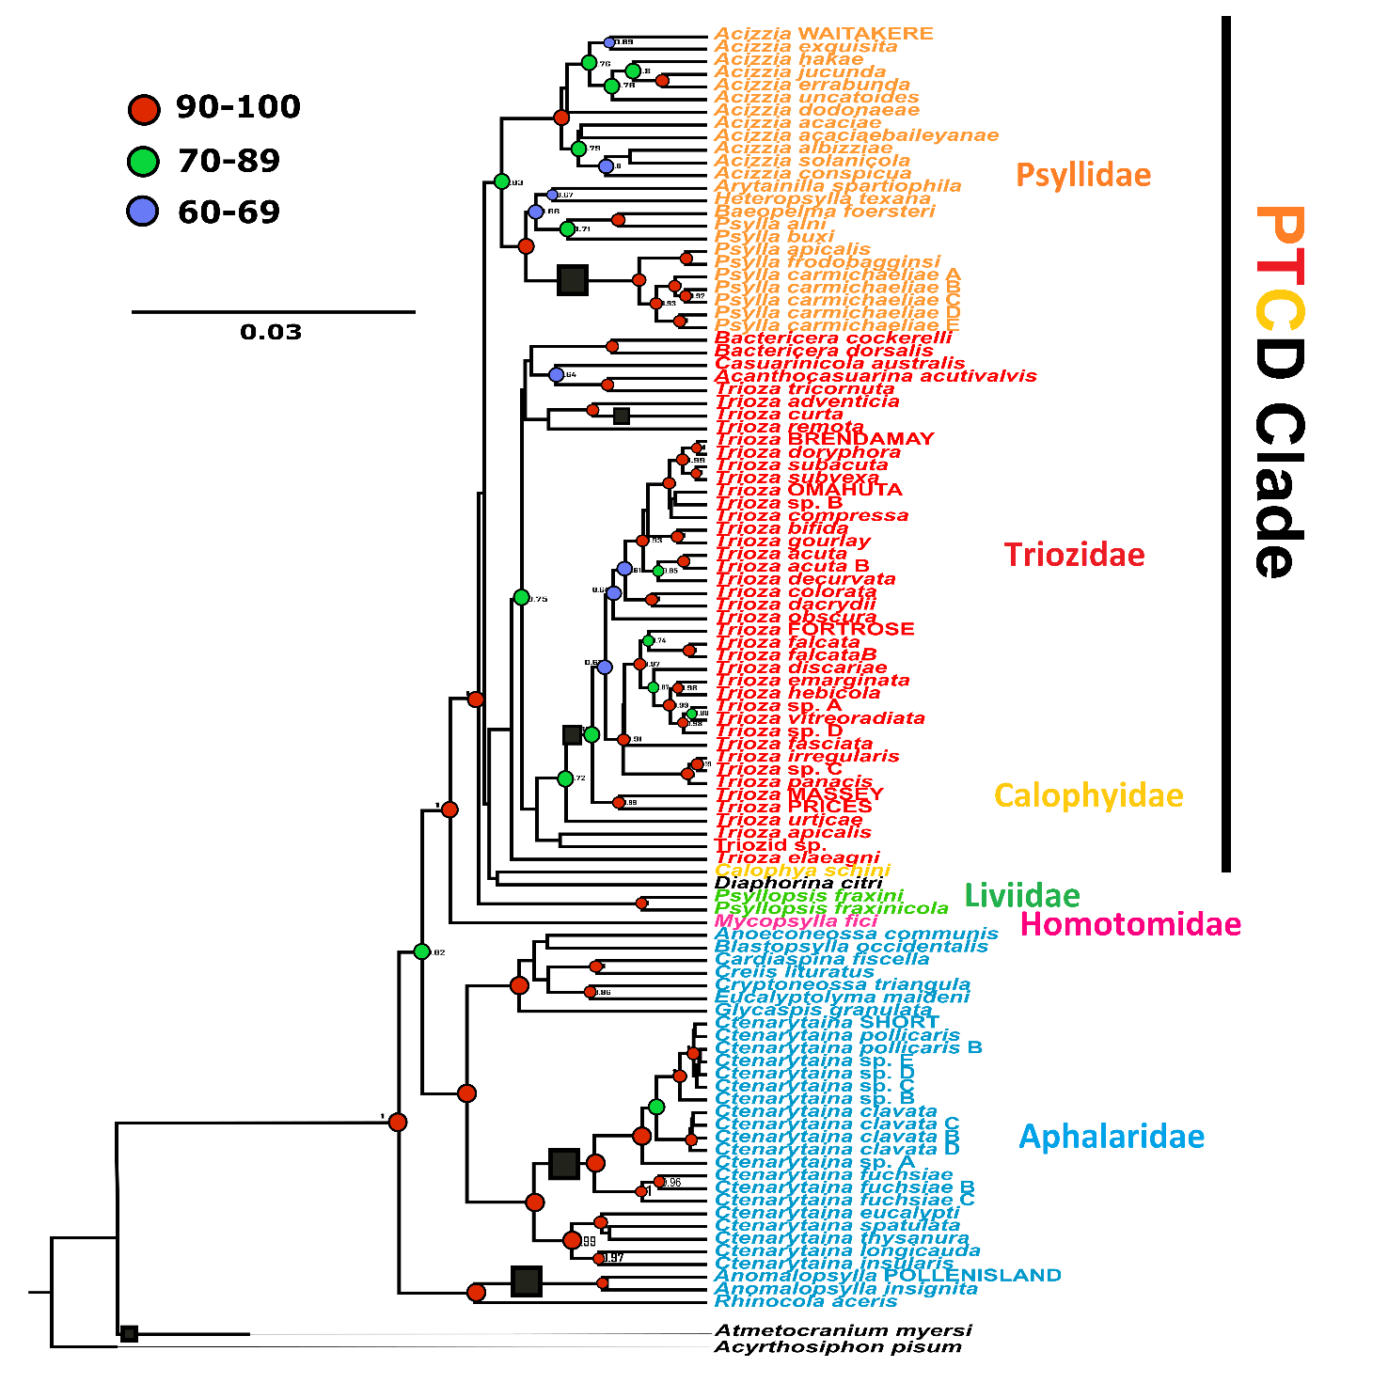

**Figure 1:** **Species tree of the New Zealand Psylloidea included in this study.** The tree was inferred from 668 DNA sequences of partial COI, EF-1α and 18S genes using BEAST v.2.5.0. The families Psyllidae (orange), Triozidae (red) and Calophyidae (*Calophya schini;* yellow), together with *Diaphorina citri* (black) form the PTCD clade, as reported in (Percy *et al.* 2018). *Acyrthosiphon pisum* (Hemiptera) was used as an out group. New Zealand endemic species are indicated with black squares on branches showing ancestral arrivals of native species. Posterior probability values at the nodes are reported in red when ranging between 0.9 and 1; in green when between 0.7 and 0.89; and in blue when between 0.6 and 0.69. Posterior probability values lower than 0.6 are not reported.

* 1. ***Microbiome results***

**Bacterial diversity**

Following sequence quality filtering and curation a total of 9,258,360 sequences were retailed from 246 specimens of 74 taxa (mean = 37636; se = 2503; range = 1177-231159) consisting of 621 unique amplicon sequence variants (ASVs) (mean =42.3; se=1.52; range = 5-151). The ASV’s recovered represented 21 distinct bacterial phyla and 126 unique genera. The most prevalent bacterial phylum was Proteobacteria (all 246 specimens), followed by Bacteroidota (237 specimens), Actinobacteriota (192 specimens) and Firmicutes (165 specimens). This was similarly reflected in their abundance, with Proteobacteria also being the most abundant bacterial phylum, accounting for 8,486,237 sequence reads (91% of dataset), followed by Bacteroidota (2.6%), Firmicutes (1.07%), and Actinobacteriota (0.4%). Within the phylum Proteobacteria, the orders *Burkholderiales*, *Rhizobiales*, Gammaproteobacteria *Incertae Sedis* (an order within the Silva 138 taxonomy containing the primary symbiont *Candidatus* Carsonella) and *Enterobacterales* were the most prevalent, while *Enterobacterales*, *Rikketsiales* and *Pseudomonadales* were the most abundant (Fig 2). At the genus level, the most abundant taxon was *Wolbachia*, which occurred in a high titre across many samples and accounted for 19% of the total sequences, followed by *Sodalis* (8.2%) and *Arsenophonus* (5.4%). In contrast, the most prevalent genera were *Aquabacterium* (233 specimens), *Candidatus* Carsonella (217 specimens), *Sulfuriatalea* (208 specimens) and *Sediminibacterium* (199 specimens).

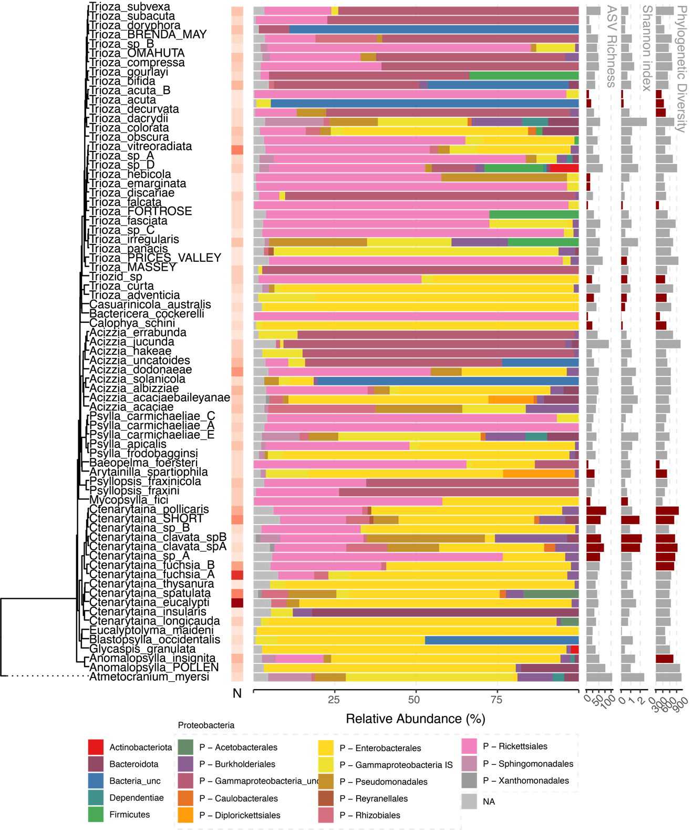

**Figure 2:** Overview of microbiome results by species

Alpha diversity

ANOVA found statistically significant differences between psyllid species for observed ASV richness (F(73, 172) = 2.47, p < .001), Shannon’s index (F(73, 172) = 3.02, p < .001), and phylogenetic diversity (F(73, 172) = 2.72, p < .001), all with large effects (partial omega squared = 0.37, 0.37 and 0.34 respectively). The differences in ASV richness was found to be significantly associated with psyllid phylogeny using both autocorrelation (I=0.24, p<0.001), and Brownian motion statistics (K = 0.34, λ = 0.84 p<0.001). Similar result was found for Shannon’s index (I= 0.018, K=0.21, λ = 0.78, p<0.001). On the other hand, the phylogenetic diversity of microbes within each psyllid sample was not found to be significantly autocorrelated with phylogeny with most measures (I= 0.009, p=0.058), K=0.08, p=0.11, λ = 0.648, p<0.05). Significant local autocorrelation between richness and Shannon’s index, and the psyllid phylogeny was concentrated around the *Ctenarytaina clavata* clade, and the *Trioza* *acuta* clade (Figure 2). To ensure robustness to different sample sizes, the data was rarefied to the smallest sample and these tests repeated, with the same conclusions (Supplementary Figures 1a and 1b).

Beta diversity & Phylosymbiosis

For microbial beta diversity, visual inspections of PCA plots on the microbiome Aitchison distances (Supplementary Figure 2A, 2B and 2C) indicated that a mixture of both and dispersion effects are likely to play a role in the differences between the microbiomes (Figure 2). This was supported by permutation tests on the distance matrices, with the taxonomic label of their psyllid host explained significant variance (Adonis, R2 = 0.47, p<0.001), as well as s differences in dispersion (PERMDISP). The taxonomic annotation of the hostplant that each psyllid specimen was collected off also explained a significant amount of variance (Adonis, R2 = 0.35, p<0.001) and dispersion (PERMDISP), however less than the psyllid taxon label. For the psyllid specimens that were collected off the same individual hostplants, the hostplant they were collected from explained a small amount of variance (R2= 0.009, p<0.05), while their taxonomic name continued to explain the largest portion of the variance (R2 = 0.52, P< 0.001). To determine if the significant effect of psyllid and hostplant species on microbiome composition was due to shared evolutionary history, matrix correlation tests were conducted between the microbiome beta diversities and the psyllid phylogenetic distance, hostplant phylogenetic distance and spatial distance. Mantel tests found significant positive correlation between microbiome and psyllid phylogenetic distance (r=0.23, p<0.001) but no significant correlation between microbiome and hostplant phylogenetic distance (r=0.04, p=0.19), or microbiome and spatial distance (r=0.02, p=0.65) (Figure 3A). Similarly, partial mantel tests found significant positive correlation between microbiome and psyllid phylogenetic distance when hostplant distance and spatial distance were controlled for (r=0.22, p<0.001), and found no significant correlation between microbiome and hostplant phylogenetic distance, when psyllid phylogenetic distance and spatial distance were controlled for (r=-0.02, p=0.55) or spatial distance when psyllid and hostplant phylogenetic distances were controlled for (r=0.024, p=0.65) (Figure 3B). To ensure patterns of phylosymbiosis were not being driven only by the known symbionts, correlation analyses were repeated without the class Gammmaproteobacteria, that includes both the primary and secondary symbionts. With this subset data a significant albeit reduced correlation was found between the microbiome and psyllid phylogenetic distance for both Mantel (r=0.2, p<0.05) and Partial Mantel tests (r=0.2, p<0.05), while hostplant and spatial distance remained insignificant (supplementary n).

**Figure 3:** Phylosymbiosis – Results of Mantel tests (**A**), partial Mantel tests (**B**), and beta diversity through time analysis (**C**).

In order to investigate the phylogenetic scale of the phylosymbiosis patterns, beta diversity through time analysis was used to slice the microbiome phylogeny at 10Mya timepoints and recalculate partial Mantel correlations. Microbiome beta diversity and psyllid phylogenetic distance remained significantly correlated at all time-slices with the correlation peaking at approximately 100 Mya, before falling to a plateau at approximately 500Mya (Figure 3C). In contrast, the correlation between microbiome and hostplant phylogenetic distance, as well as microbiome and spatial distance was not significant at any point in the time slices.

Cophylogeny

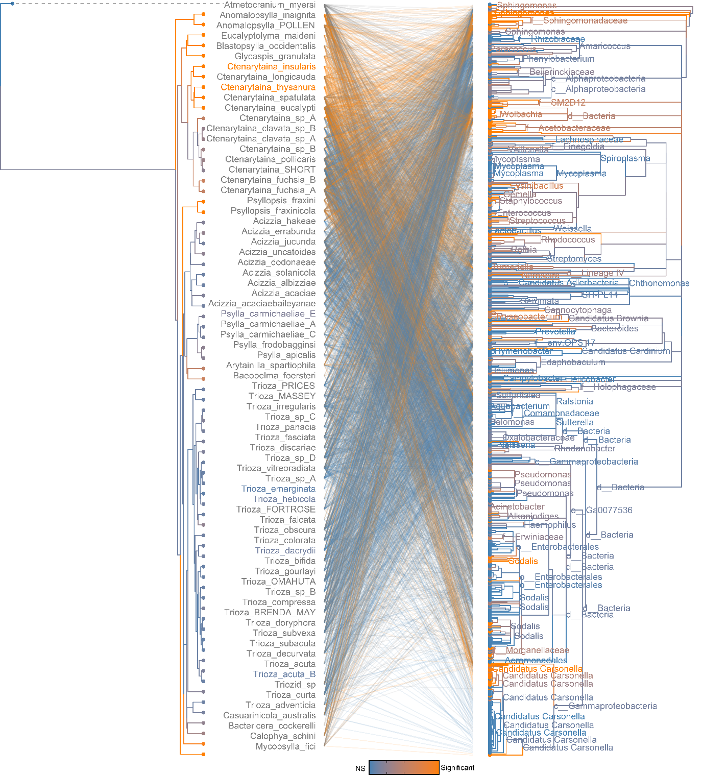

**Figure 4**: Phylogenetic congruence between psyllid species and microbiome. Links and taxa coloured according to their contribution to PACo global fit.

The cophylogenetic signal between the psyllid phylogeny and the microbiome phylogeny was compared using ParaFit and PACo algorithms. While the global fits for both the ParaFit statistic and PACo goodness-of-fit were low (ParaFitGlobal=2695,920) and ( m2xy=0.9931) respectively, the observed interaction network between the psyllid and microbial taxa was still found to be significantly more congruent than any of the 100,000 permuted instances using both algorithms (p<0.001). Low global fits are common with complex interaction networks such as when comparing a whole microbiome (ref), and when looking at contributions of individual interactions, 1498 interactions were found to be significant with ParaFit, and 1180 interactions with PACo (Figure 4). On the microbial side, unsurprisingly many links associated with the primary symbiont *Candidatus* Carsonella rudii were found to show congruence with a hypothesis of cophylogeny. However, in addition to the primary symbiont, other bacterial genera showed a higher number of significant links from both ParaFit and PACo, including *Reyreanella*, *Novosphingobium*, *Sphingomonus* and *Wolbachia* (Figure 4; Figure 5). While many of these taxa were not as prevalent across psyllid specimens as *Carsonella*, they could represent secondary symbionts. When the PACo algorithm was fit between the psyllid species and the *Candidatus* Carsonella ASVs alone, the goodness-of-fit between the two phylogenies was much higher than seen in the entire assemblage for both Parafit (ParaFitGlobal=2032.17, p<0.001) and PACo (m2xy=0.15, p<0.001) (Supplementary Figure 3). In addition to the significant signal between psyllids and their associated microbiome, cophylogenetic significant congruences were also seen between the psyllids and their hostplant species for both ParaFit (ParaFitGlobal=1451.17, p<0.001) and PACo (m2xy=0.53, p<0.001) (Supplementary Figure 4).

When these algorithms were again fit to just psyllids of the *Trioza* genus and their associated microbiome (Supplementary Figure 5), ParaFit still inferred a significant but slight congruence between the two phylogenies and interaction network (ParaFitGlobal=109,615.2, p<0.001) (Figure 6), however this time the PACo goodness-of-fit statistic was not significant (m2xy=0.9911, p>0.05) compared to the 100,000 randomisations. Once again when looking at the individual interactions a number of significant interactions stood out such as the microbial genera *Reynarella*, *Wolbachia*, *Novosphingobium* and *Candidatus* Carsonella. Interestingly, the genus *Mycoplasma* appeared to have a strong significance (Figure 6). While on the *Trioza* tree, the taxa with the highest number of significant links were *Trioza* “Prices Valley”, *T.* “Massey” and *Trioza curta* and *T. adventicia*. When ParaFit and PACo were refit to the *Trioza* and just the *Candidatus* Carsonella ASV’s the congruence found with both algorithms was increased compared to that seen between with the larger psyllid dataset, but to a higher degree with ParaFit (ParaFitGlobal=46.39, p<0.001) than PACo (m2xy=0.13, p<0.001) (Supplementary Figure 6). Similarly, the congruence between the *Trioza* and their hostplants was increased compared to the larger dataset with both algorithms (ParaFitGlobal=109.83, m2xy=0.48, p<0.001) (Supplementary Figure 7).

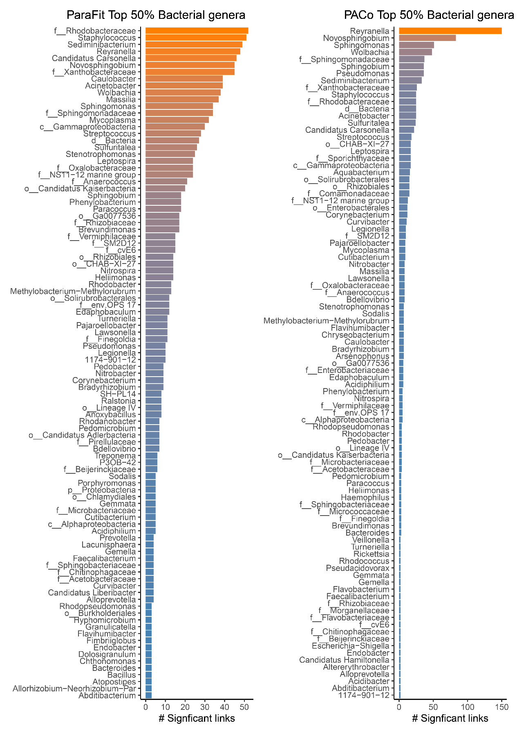

**Figure 5:** Number of significant links from each microbial genus contributing to phylogenetic congruence between psyllid species and their microbiome for both ParaFit and PACo

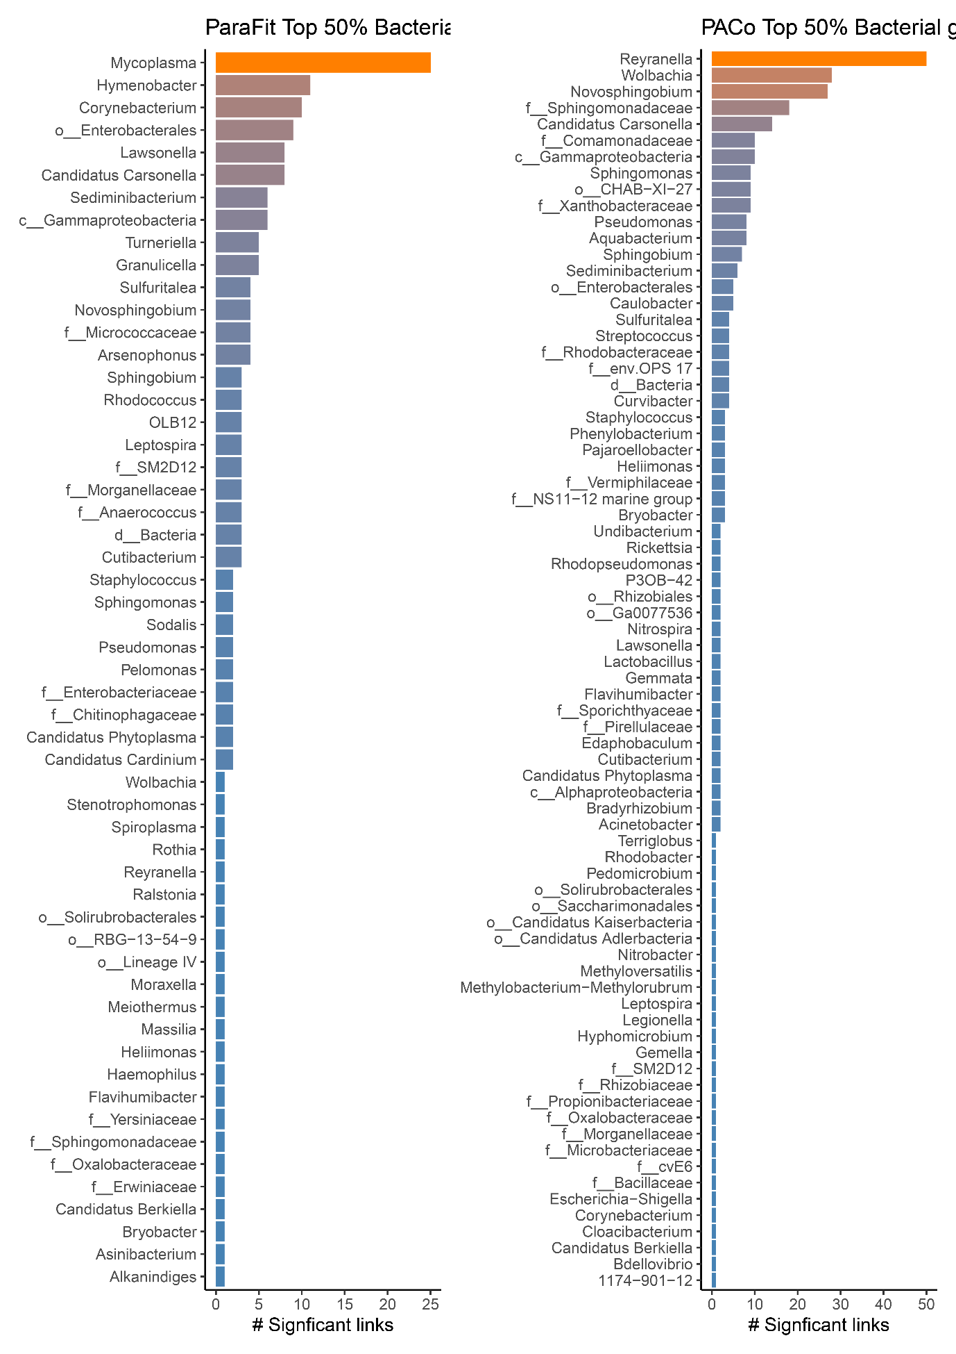

**Figure 6:** Number of significant links from each microbial genus contributing to phylogenetic congruence between Trioza species and their microbiome for both ParaFit and PACo

1. **Discussion**
   1. ***The philogenetic structure of the New Zealand psyllids confirms monophylies and Ancestral arrivals of today’s New Zealand endemic psyllids.***

The general shape of the species tree, especially at a taxonomic level, matches the most recent phylogenetic works on the worldwide Psylloidea at a family level (e.g., Percy *et al.* 2018; Cho *et al.* 2019). The families Psyllidae, Triozidae and Calophyidae, together with the species *Diaphorina citri,* form the PTCD clade (Percy *et al.* 2018), at the top of the tree, and were separated from the family Liviidae, represented in New Zealand by the two non-native species of the genus *Psyllopsis*, with maximum posterior probability support (Figure 1). Similarly, the family Homotomidae is represented by a single adventive species, *Mycopsylla fici,* branching with maximum posterior probability (Figure 1). At the base of the tree, the family Aphalaridae appears to be paraphyletic, with the subfamily Rhinocolinae branching earlier than the Spondyliaspidinae, in accordance with the most recent works (Cho *et al.* 2019). Separated from all the other families, a single branch that included the species *Atmetocranium myersi* showed no affinity to any other group. Therefore, the species tree obtained here appears robust and well supported at both deeper and shallower nodes, despite the use of a relatively small number of markers, supporting the previously defined taxonomic relationships between species, genera and families, as defined by their morphological characteristics (Burckhardt and Ouvrard 2012). Hence, this phylogenetic structure can be used further for comparisons and to determine evolutionary history for a number of New Zealand psyllid groups.

Many New Zealand insect taxa are known to have been derived by dispersal rather than vicariance (Goldberg *et al.* 2008, Buckley *et al.* 2015). Previous work on the origin and evolution of the New Zealand psyllids (Dale 1985) regarded the presence of genera common to New Zealand, New Caledonia, Australia or South America (i.e. *Ctenarytaina* and *Psylla*) as a possible explanation for a Gondwanan origin for these insects (Dale 1985), as opposed to a dispersal. This interpretation was probably influenced by the now outdated view that the New Zealand native biota was primarily a product of long-standing geographical isolation resulting from the Gondwanan split, happened approximately 80 Mya (Goldberg *et al.* 2008). Based on the molecular phylogeny presented here, we could confirm monophyly for a number of New Zealand native psyllid genera, suggesting the present fauna of these groups is the results of separate arrivals into the region.

This study suggests that all New Zealand *Trioza* species (except *T. curta*) form a monophyletic grouping that appears to have come from a single arrival to New Zealand. These New Zealand *Trioza* were not clearly related to the Australian triozids represented here. However, the Australian triozids are also distant from one another, suggesting that they may not be a natural monophyletic group. This could be the result of a previous arrival to Australia by multiple dispersals or it could suggest they are the remnants of a larger Australian group that has lost members over time.In order to understand the origin of the New Zealand *Trioza* a more complete sampling of triozids from the Asia-Pacific is required. In particular, it would be advantageous to study *T. oleariae* Froggatt 1903, from Tasmania which is hosted by *Olearia* (Asteraceae) (Hollis 2004), as are many of the New Zealand *Trioza*. Consequently, T. curta appears to be from a second distinct ancestral arrival or even of Australian origin, considering how it appears to be genetically similar to *T. adventicia.*

Another example of monophyly that suggests a separate arrival is presented by the genus *Psylla,* recording seven species in New Zealand, while being absent in Australia. The identity of New Zealand *Psylla* species has been hypothesised to be different to that of their European counterparts based on morphological characters, possibly placing them in a new genus (Martoni *et al.* 2016). The results obtained here appear to be in agreement with this hypothesis, showing a well-supported separation between the New Zealand species and their European counterparts. The two other *Psylla* species in the analysis, *P. buxi* and *P. alni* from Europe, were relatively distant from the New Zealand taxa. The fact that the European *Psylla* appear more closely related to other genera in the Psyllidae (*Baeopelma* and *Arytainilla* - subfamily Psyllinae; *Heteropsylla* subfamily Ciriacreminae) than they are to the New Zealand *Psylla* (subfamily Psyllinae) is consistent with the hypothesis that the New Zealand clade belong to an entirely different genus. Morphological characters such as 8-segmented antennae and marginal setae on the caudal plate place New Zealand *Psylla* within the Psyllinae but outside *Psylla* (Martoni *et al.* 2016). Nevertheless, the taxa included here are insufficient to determine the closest relatives of the New Zealand *Psylla*; inclusion of those from Fiji and the Asia/Pacific region would be necessary.

A fourth arrival is hypothesised here for the New Zealand species of the genus *Ctenarytaina.* There are five *Ctenarytaina* species in Australia (Ouvrard 2019) and the fact a number of other psyllids species arrived in New Zealand from there in recent times (Martoni *et al.* 2016), an Australian origin of the New Zealand *Ctenarytaina* species could be hypothesised. Nonetheless, a number of *Ctenarytaina* species are also distributed across the Pacific islands, e.g. *C. distincta* (Tuthill, 1943) from Fiji, *C. lulla* Tuthill, 1942 and *C. remota* Tuthill, 1956 from French Polynesia (Ouvrard 2019; Tuthill, 1942, 1943, 1956), which highlights the importance of wider geographic collections in the future, as already stated elsewhere (Martoni and Armstrong 2019a). Possible alternative sources to Australia is also consistent with the fact that there are no *Psylla* in Australia (Hollis 2004; Ouvrard 2019). But their worldwide presence includes *P. compta* Crawford, 1919 in Fiji as the closest location to New Zealand (Ouvrard 2019).

A fifth ancestral arrival is that of the genus *Anomalopsylla.* The phylogenetic position of *Anomalopsylla* here is consistent with recent taxonomic classifications placing this genus in the family Aphalaridae. Polyphyly of this family is consistent with the subfamily division, with the subfamily Rhinocolinae (including *Rhinocola* and *Anomalopsylla* - Burckhardt and Ouvrard 2012) separated from the Spondyliaspidinae (all other genera). While the subfamily Rhinocolinae includes 13 genera distributed worldwide (Burckhardt and Lauterer, 1989), *Anomalopsylla* is the only genus present in the Asia-Pacific area and the only one hosted by Asteraceae. The addition to the analysis of the European species *Rhinocola aceris* highlighted how this species is relatively phylogenetically close to *Anomalopsylla.*

The sixth ancestral arrival is *Atmetocranium myersi,* the only representative of this genus. This species showed no phylogenetic affinity with any other psyllid species or family.In a recent morphological classification of the Psylloidea, *Atmetocranium* was tentatively placed within the Calophyidae, because of its distinctive metatibia (Burckhardt and Ouvrard 2012). The Calophyidae includes at least 118 species (Ouvrard 2019), but none are native to New Zealand. *Atmetocranium* was earlier placed with the Aphalaridae, based on wing morphology (Klimaszewski 1964). Based on the results obtained here, it would appear that it does not belong to any of the Aphalaridae subfamilies included here. Samples from the other three subfamilies (Aphalarinae, Pachypsyllinae and Togepsyllinae) will need to be analysed before a linkage between *Atmetocranium* and Aphalaridae can be dismissed. Furthermore, the superfamily Psylloidea includes another two families not present in New Zealand, Carsidaridae and Phacopteronidae (Burckhardt and Ouvrard 2012), that appear to be genetically close to the family Aphalaridae (Percy *et al.* 2018). However, *A. myersi* has also been noted as having a “highly autapomorphic morphology which makes it difficult to relate to other psylloid groups” (Mifsud and Burckhardt 2002). This detail appears to be in agreement with the results obtained here, showing a clear separation between *Atmetocranium* and all the other psyllid families presented in this study. This, together with its peculiar morphology (Mifsud and Burckhardt 2002), suggest that *Atmetocranium* could belong to an entirely new psyllid family.

* 1. ***The microbial diversity harboured by the New Zealand psyllids***

*Microbiome diversity*

The microbial dataset generated and analysed here included 246 psyllids, belonging to 65 species, 18 genera and six families. This is a significant advance on that of previous such studies that either focused on a smaller taxonomic range of insects, such as the Australian genus *Cardiaspina* (Hall *et al.* 2016) or used different techniques that generated smaller numbers of sequences (Thao *et al.* 2000b, Spaulding and von Dohlen 2001).

The bacterial phylum Proteobacteria was that only one present in all samples (all 246) and also the one accounting for the highest number of reads (91% of the total). This is consistent with the expectation, based on the fact both the p-symbiont and the S-symbionts belong to this group. Indeed, within Proteobacteria, the most prevalent orders were Enterobacterales, Burkholderiales, Rhizobiales and an undescribed order listed as ‘Gammaproteobacteria Incertae Sedis’ (an order within the Silva 138 taxonomy containing the primary symbiont *Candidatus* Carsonella). Similarly, Enterobacterales, Rikketsiales and Pseudomonadales were also the most abundant. At the genus level, the most abundant taxon was *Wolbachia*, often occurring at a high titre across many samples (19% of the total sequences). As previously reported in other psyllids (Hall *et al.* 2016). Previously recorded S-symbionts (Thao *et al.* 2000b; Hall *et al.* 2016) that were found here are *Sodalis* (8.2% of total reads) and *Arsenophonus* (5.4% of total reads). The role of such generaas S-symbionts of insects has been widely reported for other insects, such as Glossinidae flies (Diptera) (Aksoy *et al.* 1997), lygaeid stinkbugs (Matsuura *et al.* 2012) and a weevil (Heddi *et al.* 1998). This may explain why all Enterobacteriaceae have been previously assumed as S-symbionts of psyllids as well (e.g., Thao *et al.* 2000b; Hall *et al.* 2016). Ultimately, the results obtained here suggest that some Enterobacteriaceae S-symbionts of psyllids have a strong history of coevolution with the members of this insect superfamily.

In contrast, the most prevalent genera were *Aquabacterium* (233 specimens), *Candidatus* Carsonella (217 specimens), *Sulfuriatalea* (208 specimens) and *Sediminibacterium* (199 specimens). Given the obligate status of *Candidatus* Carsonella rudii as primary symbiont in psyllids (Thao et al. 2000a, Thao et al. 2001, Hall et al. 2016), this was expected to be found in all psyllids but was recorded only in 217 specimens. This might be due to its generally low relative abundance within all samples and high deviation (mean= 5.8%, sd=14.1%). This absence in certain specimens could be due to stochastic processes and insufficient sequencing depth.

The Psyllids-bacteria relationship: a new case of phylosymbiosis.

After confirming that the microbial composition of psyllids was not randomly distributed (alpha and beta diversity, using ANOVA) we could associate this variation with psyllid phylogeny (based on autocorrelation, Brownian motion statistics and Shannon’s index). However, despite being at a lesser degree, also the host plant taxonomic annotation could account for a significant variance as well as species difference in dispersion (using both Adonis and PERMDISP). This is in accordance with the fact that psyllids are extremely species-specific in their host plant associations. While it was expected to have both factors (insects’ and plants’phylogeny) influencing the microbiome diversity, we wanted to determine which was the main driver of microbiome composition. Therefore, we used both Mantel and partial Mantel tests.

Both Mantel and partial mantel tests, found a significant correlation between microbiome and psyllid phylogenetic distance being stronger than that between microbiome and host plant phylogenetic, suggesting that the microbiome composition is influenced at a higher degree by the psyllids phylogenetics. However, this result could have been biased by strong co-evolutive relationship between psyllids and their primary and secondary symbionts, known to be vertically transmitted (Hall *et al.* 2016). We decided to test the role of other bacteria within the psyllids microbiome, once the known primary and secondary symbionts had been excluded.

In order to test this, we removed all the Gammaproteobacteria, including *Candidatus* Carsonella and all the secondary symbionts belonging to the Enterobacteriales (e.g., *Sodalis*) and we performed the same tests on the remaining bacterial diversity. This second analysis confirmed that the remaining microbiome diversity could still be associated to the psyllid phylogenetic history, confirming such relationship is not driven solely by primary and secondary symbionts (despite these having a major role in it). Furthermore, these analyses allowed us to highlight a few groups of bacteria having a possible symbiotic role in psyllids despite having never being considered symbionts. For example, in addition to the primary symbiont, other bacterial genera showed a higher number of significant links from both ParaFit and PACo, including *Reyreanella*, *Novosphingobium*, *Sphingomonus* and *Wolbachia*. While many of these taxa were not as prevalent across psyllid specimens as *Carsonella*, they are hypothesised here to be secondary symbionts of psyllids.

Previous studies focusing both on the P-symbiont (Thao et al. 2000a, Spaulding and von Dohlen 2001, Thao et al. 2001, Hall et al. 2016) and on the S-symbionts (Thao et al. 2000b, Hall et al. 2016, Morrow et al. 2017), showed different degrees of association between psyllids and these two groups of bacteria. This includes recent studies confirming degrees of vertical transmission for a few S-symbionts in addition to the primary one (Hall et al. 2016). Based on the results obtained here, we hypothesise that vertical tranmission is the most probable mean of transmission of many more bacteria than previously reported.

* 1. ***Psyllid-bacteria-hostplants: the case of the New Zealand Trioza***

Confirming a trend widely accepted elsewhere for psyllids (e.g., Ouvrard *et al.* 2015), New Zealand *Ctenarytaina* and *Psylla* are associated with only one or a few host plant families (Burckhardt *et al.* 2014). On the other hand, worldwide, *Trioza* shows an unusually large range of plant genera associations, with a recent study listing 346 *Trioza* psyllid species on 154 plant genera in 59 plant families (Ouvrard *et al.* 2015). However, it was unclear so far if *Trioza* psyllids are more prone to host switching, or if the potentially polyphyletic nature of this genus may distort the breadth of host plant associated with this genus (Ouvrard *et al.* 2015). The New Zealand species were known to be consistent with the worldwide genus in that they do occupy many different host plant families (Martoni *et al.* 2016), but the lack of a phylogenetic structure could not clarify if the genus was monophyletic.

The results of this phylogenetic analysis suggest the monophyly of the New Zealand *Trioza*, hence demonstrating that *Trioza* species have indeed acquired a large number of new hosts since arriving in New Zealand, and that this is not a case of polyphyly. Therefore, pairing the phylogeny of the New Zealand *Trioza* analysed in this study with their host plants shows for the first time how the radiation of the psyllids developed on multiple plant genera and families after the arrival of the first ancestral *Trioza* psyllid to New Zealand.

For example, the psyllids’ association with the most common host plant family (Asteraceae), hosting 14 *Trioza* species, appears to be the result of multiple colonization events from these insects. With a cluster of 12 closely related psyllid species positioned apically in the tree (Supplementary Figure 7) suggesting a more recent colonization event as compared to the association between *T.* “Massey” or *T.* “Fortrose”, distant from the other Asteraceae feeding psyllids. Similarly, a single psyllid species in the cluster, *T. decurvata*, is found on *Dracophyllum* (Ericaceae) which, although positioned within the same major plant clade as the Asteraceae, is remote from it. Prior to this study, Asteraceae had been thought to be the ancestral host of New Zealand *Trioza* based on morphology and host associations (Martoni *et al.* 2016). However, the host association with Asteraceae was not clear-cut; while one of the earliest diverging species, *T.* “Massey” has an Asteraceae host, most of the remaining Asteraceae inhabiting psyllids appeared to have derived from a more recent host adoption/speciation event. Another example is the association between the psyllids *T. colorata* and *T. dacrydii* with the Podocarpaceae (*Halocarpus bidwillii*), a conifer lineage. These two psyllid species are branching within the broader clade of *Trioza*, suggesting a shift from an angiosperm host within New Zealand.

When comparing the phylogenetic congruence between the *Trioza* species and their microbiome (Supplementary Figure 5), the taxa contributing more significantly to the PACo global fit are the the two branching earlier in time: *Trioza* ‘Price’s Valley and *T.* ‘Massey’. This might suggest how these more archaic triozids carry a microbiome diversity strictly linked.

When examining the microbial composition of the *Trioza* species, a few bacterial genera were highlighted for having a strong presence across species and, therefore, a potential role in their ecology. Amongst these genera were *Mycoplasma, Hymenobacter, Corynebacterium, Reyranella, Wolbachia* and *Novosphingoboium.* Considering the peculiar multi-host plant associations recorded for the genus *Trioza* in New Zealand, these bacteria might play an important role in the host plant association of these psyllid species, possibly allowing and/or facilitating host switches.

1. ***Conclusion.***

Based on the results obtained here, we suggest that the psyllid-microbiome associations are strongly influenced by the insects’ phylogenetic relationships as opposed to the host plant association. This is confirmed by the present phylosymbiotic signal recorded between the New Zealand psyllids and their microbiomes, highlighting the major role of vertically transmitted bacteria, playing an important part in shaping the psyllids microbiome composition. Furthermore, while vertical transmission was previously hypothesised only for P-symbiont and a few S-symbionts, we reported here that a much bigger percentage of the microbiome of psyllids has been co-evolving with their hosts.

**Acknowledgements.**

The authors would like to acknowledge the support of the Australian Plant Biosecurity Research Centre (PBCRC). Thanks to Susan Halbert (FSCA) for helping FM collecting psyllids in Florida, USA. Thanks to Marona Rovira Capdevila, Samuel Brown for helpful suggestions. Part of the data published in this article was reported in FM’s PhD thesis (Martoni 2017).

**References.**

* Abouheif, E. 1999. A method for testing the assumption of phylogenetic independence in comparative data. *Evolutionary Ecology Research*, 1: 895–909.
* Ahmed, M.Z., Breinholt, J.W. & Kawahara, A.Y. 2016. Evidence for common horizontal transmission of Wolbachia among butterflies and moths. *Bmc Evolutionary Biology*, 16: 118. https://doi.org/10.1186/s12862-016-0660-x.
* Aitchison, J., Barceló-Vidal, C., Martín-Fernández, J.A. & Pawlowsky-Glahn, V. 2000. Logratio analysis and compositional distance. *Mathematical Geology*, 32(3): 271-275.
* Aksoy, S., Chen, X. & Hypsa, V. 1997. Phylogeny and potential transmission routes of midgut-associated endosymbionts of tsetse (Diptera: Glossinidae). *Insect Molecular Biology*, 6: 183-190.
* Anselin, L. 1995. Local indicators of spatial association—LISA. *Geographical analysis*, 27(2): 93-115.
* Balbuena, J. A., Míguez-Lozano, R., & Blasco-Costa, I. 2013. PACo: a novel procrustes application to cophylogenetic analysis. *PLOS ONE*, 8(4).
* Baumann, P. 2005. Biology of bacteriocyte-associated endosymbionts of plant sap-sucking insects. *Annual Review of Microbiology*, 59: 155-189.
* Bekker-Migdisova, E.E. 1973. *Systematics of the Psyllomorpha and the position of the group within the order Homoptera*. In: Narchuk, E.P. (Ed.), Doklady na Dvadsat Chetvertom Ezheghodnom Chtenii Pamyati N. Voprosy paleontologii nasekomykh, Leningrad, pp. 90-117.
* Bennett, A.E. 2013. Can plant–microbe–insect interactions enhance or inhibit the spread of invasive species? *Functional Ecology*, 27: 661–671
* Bivand, R.S., Pebesma, E.J. & Gomez-Rubio, V. 2013. *Applied spatial data analysis with R*, Second edition. Springer, NY. 376 pp.
* Blomberg S.P., Garland T.Jr. & Ives A.R. 2003. Testing for phylogenetic signal in comparative data: behavioral traits are more labile. *Evolution*, 57: 717–745.
* Bouckaert, R., Heled, J., Kühnert, D., Vaughan, T., Wu, C-H., Xie, D., Suchard, M.A., Rambaut, A. & Drummond, A.J. 2014. BEAST 2: A Software Platform for Bayesian Evolutionary Analysis. *PLOS Computational Biology,* 10(4), e1003537. doi:10.1371/journal.pcbi.1003537.
* Bouckaert, R., Vaughan, T.G., Barido-Sottani, J., Ducheene, S., Fourment, M., Gavryushkina, A., Heled, J., Jones, G., Kuhnert, D., De Maio, N., Matschiner, M., Mendes, F.K., Muller, N.F., Ogilvie, H., du Plessis, L., Popinga, A., Rambaut, A., Rasmussen, D., Siveroni, I., Suchard, M.A. & Wu, C.-H. 2018. BEAST 2.5: An Advanced Software Platform for Bayesian Evolutionary Analysis. *bioRxiv preprint*, first posted online Nov. 19, 2018; doi: <http://dx.doi.org/10.1101/474296>.
* Brooks, A.W., Kohl, K.D., Brucker, R.M., van Opstal, E.J. & Bordenstein, S.R. 2016. Phylosymbiosis: Relationships and Functional Effects of Microbial Communities across Host Evolutionary History. *PLOS Biology*, 15(1): e1002587. https://doi.org/10.1371/journal.pbio.1002587
* Brown, R.G. & Hodkinson, I.D. 1988. Taxonomy and Ecology of the Jumping Plant-Lice of Panama (Homoptera: Psylloidea). *Behaviour*, 107: 131-131.
* Brucker, R.M. & Bordenstein, S.R. 2012. Speciation by symbiosis. *Trends in Ecology and Evolution*, 27(8): 443-451.
* Buckley, T.R., Krosch, M. & Leschen, R.A.B. 2015. Evolution of New Zealand insects: summary and prospectus for future research. *Austral Entomology*, 54: 1-27.
* Burckhardt, D.& Lauterer, P. 1989. Systematics and biology of the Rhinocolinae (Homoptera: Psylloidea). *Journal of Natural History*, 23(3): 643-712, DOI: 10.1080/00222938900770371
* Burckhardt, D. & Ouvrard, D. 2012. A revised classification of the jumping plant-lice (Hemiptera: Psylloidea). *Zootaxa,* 3509: 1–34
* Burckhardt, D., Ouvrard, D., Queiroz, D. & Percy, D. 2014. Psyllid Host-Plants (Hemiptera: Psylloidea): Resolving a Semantic Problem. *Florida Entomologist*, 97: 242-246.
* Bushnell, B. 2017. BBMap website, available at: sourceforge.net/projects/bbmap/
* Callahan, B.J., Sankaran, K., Fukuyama, J.A., McMurdie, P.J. & Holmes, S.P. 2018. Bioconductor Workflow for Microbiome Data Analysis: from raw reads to community analyses [version 2; referees: 3 approved]
* Chamberlain, S. 2019. brranching: Fetch 'Phylogenies' from Many Sources. R package version 0.5.0. <https://CRAN.R-project.org/package=brranching>.
* Cho, G., Malenovsky´, I., Lee, S. 2019. Higher-level molecular phylogeny of jumping plant lice (Hemiptera: Sternorrhyncha: Psylloidea). *Systematic Entomology*, https://doi.org/10.1111/syen.12345 PMID: 30988552.
* Chu, C.C., Spencer, J.L., Curzi, M.J., Zavala, J.A. & Seufferheld, M.J. 2013. Gut bacteria facilitate adaptation to crop rotation in the western corn rootworm. *Proceedings of the National Academy of Sciences of the United States of America*, 110: 11917-11922.
* Colman, D.R., Toolson, E.C. & Takacs-Vesbach, C. 2012. Do diet and taxonomy influence insect gut bacterial communities? *Molecular Ecology*, 10/01; 2019/04;21(20):5124-5137.
* Dale, P.J. 1985. *A review of the Psylloidea (Insecta: Hemiptera) of the New Zealand subregion*. Unpublished PhD Thesis. University of Auckland, Auckland.
* de Vienne, D.M., Aguileta, G. & Ollier, S. 2011. Euclidean nature of phylogenetic distance matrices. *Systematic biology*, 60(6), 826-832.
* Douglas, A.E. 2016. How multi- partner endosymbioses function. *Nature Reviews Microbiology*, 14: 731-743.
* Drummond, A.J. & Bouckaert, R.R. 2015. *Bayesian evolutionary analysis with BEAST*. Cambridge University Press. 249 pp.
* Drummond, A.J., Suchard, M.A., Xie, D. & Rambaut, A. 2012. Bayesian Phylogenetics with BEAUti and the BEAST 1.7. *Molecular Biology and Evolution*, 29: 1969-1973.
* Eastman, J.M., Harmon, L.J. & Tank, D.C. 2013. Congruification: support for time scaling large phylogenetic trees. *Methods in Ecology and Evolution*, 4(7): 688-691. <https://doi.org/10.1111/2041-210X.12051>.
* Edgar, R.C. 2018. Updating the 97% identity threshold for 16S ribosomal RNA OTUs. *Bioinformatics*, 34: 2371–2375.
* Fagen, J.R., Giongo, A., Brown, C.T., Davis-Richardson, A.G., Gano, K.A. & Triplett, E.W. 2012. Characterization of the relative abundance of the citrus pathogen *Ca.* Liberibacter asiaticus in the microbiome of its insect vector, *Diaphorina citri*, using high throughput 16S rRNA sequencing. *Open Microbiology Journal*, 6: 29–33.
* Faith, D.P. 1992. Conservation evaluation and phylogenetic diversity. *Biological conservation*, 61(1): 1-10.
* Ferris, G.F. & Klyver, F.D. 1932. Report upon a Collection of Chermidae (Homoptera) from New Zealand. *Transactions of the New Zealand Institute,* 63: 34–61.
* Frago, E., Dicke, M., Godfray, H.C.J. 2012. Insect symbionts as hidden players in insect-plant interactions. *Trends in Ecology & Evolution*, 27: 705-711.
* Frøslev, T.G., Kjøller, R., Bruun, H.H., Ejrnæs, R., Brunbjerg, A.K., Pietroni, C. & Hansen, A.J. 2017. Algorithm for post-clustering curation of DNA amplicon data yields reliable biodiversity estimates. *Nature communications*, 8(1): 1-11.
* Gloor, G.B., Macklaim, J.M., Pawlowsky-Glahn, V., Egozcue, J.J. 2017. Microbiome datasets are compositional: and this is not optional. *Frontiers in microbiology*, 8: 2224.
* Goldberg, J., Trewick, S.A. & Paterson, A.M., 2008. Evolution of New Zealand’s terrestrial fauna: a review of molecular evidence. *Philosophical Transactions of the Royal Society B*, 363: 3319-3334.
* Gonnella, E., Tedeschi, R., Crotti, E. & Alma, A. 2019. Multiple guests in a single host: interactions across symbiotic and phytopathogenic bacteria in phloem-feeding vectors – a review. *Entomologia Experimentalis et Applicata*, 167: 171–185. DOI: 10.1111/eea.12766.
* Goslee, S.C. & Urban, D.L. 2007. The ecodist package for dissimilarity-based analysis of ecological data. *Journal of Statistical Software*, 22(7): 1-19.
* Greenslade, P., Farrow, R.A. & Smith, J.M.B. 2001. Long distance migration of insects to a subantarctic island. *Journal of Biogeography,* 26(6): 1161-1167. https://doi.org/10.1046/j.1365-2699.1999.00356.x
* Groussin, M., Mazel, F., Sanders, J.G., Smillie, C.S., Lavergne, S., Thuiller, W. & Alm, E.J. 2017. Unraveling the processes shaping mammalian gut microbiomes over evolutionary time. *Nature Communications*, 8(1): 1-12.
* Hall, A.A.G., Morrow, J.L., Fromont, C., Steinbauer, M.J., Taylor, G.S., Johnson, S.N., Cook, J.M. & Riegler, M. 2016. Codivergence of the primary bacterial endosymbiont of psyllids versus host switches and replacement of their secondary bacterial endosymbionts. *Environmental Microbiology*, 18: 2591-2603.
* Hansen, A.K. & Moran, N.A. 2014. The impact of microbial symbionts on host plant utilization by herbivorous insects. *Molecular Ecology*, 23: 1473-1496.
* Hasegawa, M., Kishino, H. & Yano, T. 1985. Dating of human-ape splitting by a molecular clock of mitochondrial DNA. *Journal of Molecular Evolution*, 22(2): 160–174. doi:10.1007/BF02101694
* Heddi, A., Charles, H., Khatchadourian, C., Bonnot, G. & Nardon, P. 1998. Molecular characterization of the principal symbiotic bacteria of the weevil *Sitophilus oryzae*: A peculiar G+C content of an endocytobiotic DNA. *Journal of Molecular Evolution*, 47: 52-61.
* Heled, J. & Drummond, A.J. 2010. Bayesian inference of species trees from multilocus data. *Molecular Biology and Evolution*, 27(3): 570-580 doi: 10.1093/molbev/msp274.
* Heslop-Harrison, G. 1960. Contributions to our knowledge of the Psyllidae of Australia and New Zealand with special reference to Tasmania - (III). *Annals and Magazine of Natural History*, 3: 705-718.
* Hodkinson, I.D. 2009. Life cycle variation and adaptation in jumping plant lice (Insecta: Hemiptera: Psylloidea): a global synthesis. *Journal of Natural History*, 43(1): 65–179.
* Hollis, D. 1987. A review of the Malvales-feeding psyllid family Carsidaridae (Homoptera). *Bulletin of the British Museum (Natural History) Entomology,* 56: 87–127.
* Hollis, D. & Broomfield, P.S. 1989. *Ficus*-feeding psyllids (Homoptera), with special reference to the Homotomidae. *Bulletin of the British Museum (Natural History) Entomology,* 58: 131–183.
* Hollis, D. 2004. *Australian Psylloidea - Jumping Plant Lice and Lerp Insects.* ABRS, Canberra. 216 pp.
* Hosokawa, T., Kikuchi, Y., Shimada, M. & Fukatsu, T. 2007. Obligate symbiont involved in pest status of host insect. *Proceedings of the Royal Society B-Biological Sciences*, 274: 1979-1984
* Hutchinson, M.C., Cagua, E.F., Balbuena, J.A., Stouffer, D.B. & Poisot, T. 2017. paco: implementing Procrustean Approach to Cophylogeny in R. *Methods in Ecology and Evolution*, 8(8): 932-940.
* Johnson, K.P., Dietrich, C.H., Friedrich, F., Beutel, R.G., Wipfler, B., Peters, R.S., Allen, J.M., Petersen, M., Donath, A., Walden, K.K. & Kozlov, A.M. 2018. Phylogenomics and the evolution of hemipteroid insects. *Proceedings of the National Academy of Sciences*, 115 (50) 12775-12780. p.201815820.
* Keck, F., Rimet, F., Bouchez, A. & Franc, A. 2016. phylosignal: an R package to measure, test, and explore the phylogenetic signal. *Ecology and Evolution*, 6(9): 2774-2780.
* Kembel, S.W., Cowan, P.D., Helmus, M.R., Cornwell, W.K., Morlon, H., Ackerly, D.D., Blomberg, S.P. & Webb, C.O. 2010. Picante: R tools for integrating phylogenies and ecology. *Bioinformatics,* 26: 1463-1464.
* Kimura, M. 1980. A simple method for estimating evolutionary rates of base substitutions through comparative studies of nucleotide sequences. *Journal of Molecular Evolution,* 16: 111–120.
* Klimaszewski, S.M. 1964. Studia nad ukladem systemtycznym podrzedu Psylloidea. *Annales zoologici*, 22: 81-138.
* Klindworth, A., Pruesse, E., Schweer,T., Peplies, J., Quast, C., Horn, M. & Glockner, F.O. 2013. Evaluation of general 16S ribosomal RNA gene PCR primers for classical and next-generation sequencing-based diversity studies. *Nucleic Acids Research*, 41(1). doi: 10.1093/nar/gks808.
* Kohl, K.D., Varner, J., Wilkening, J.L. & Dearing, M.D. 2018. Gut microbial communities of American pikas (*Ochotona princeps*): Evidence for phylosymbiosis and adaptations to novel diets. *Journal of Animal Ecology*, 87(2): 323-330. doi: 10.1111/1365-2656.12692.
* Kumar, S., Stecher, G., Li, M., Knyaz, C. & Tamura, K. 2018. MEGA X: Molecular Evolutionary Genetics Analysis across computing platforms. *Molecular Biology and Evolution*, 35: 1547-1549.
* Lim, S.J. & Bordenstein, S.R. 2019. An introduction to Phylosymbiosis. *PeerJ Preprints*, V2, December 2019.
* Louca, S. & Doebeli, M. 2017. Efficient comparative phylogenetics on large trees. *Bioinformatics*, doi: 10.1093/bioinformatics/btx701
* Louca, S., Shih, P.M., Pennell, M.W., Fischer, W.W., Parfrey, L.W. & Doebeli, M. 2018. Bacterial diversification through geological time. *Nature ecology & evolution*, 2(9): 1458-1467.
* Macfarlane, R.P., Andrew, I.G., Berry, J.A., Johns, P.M., Hoare, R.J.B., Lariviere, M.-C., Grenslade, P., Henderson, R.C., Smithers, C.N., Palma, R.L., Ward, J.B., Pilgrm, R.L.C., Towns, D.R., McLellan, I., Teulon, D.A.J., Hitchings, T.R., Eeastop, V.F., Martin, N.A., Fletcher, M.J., Stufkens, M.A.W., Dale, P.J., Burckhardt, D. & Buckley, T.R. 2010. *Phylum Arthropoda, subphylum hexapoda: Protura, springtails, Diplura, insects. Checklist of New Zealand Hexapoda*. In Gordon, D.P. (ed.), *New Zealand Inventory of Biodiversity. Volume 2, Kingdom Animalia, Chaetognatha, Ecdysozoa, Ichnofossils.* Canterbury University Press, Christchurch, 233‒467.
* Mantel, N. 1967. The detection of disease clustering and a generalized regression approach. *Cancer Research*, 27: 209-220.
* Martoni, F. 2017. *Biodiversity, Evolution and Microbiome of the New Zealand Psylloidea (Hemiptera: Sternorrhyncha).* Ph.D. Thesis, Lincoln University, Lincoln, New Zealand, 279 pp.
* Martoni, F. & Armstrong, K. 2019a. *Acizzia errabunda* sp. nov. and *Ctenarytaina insularis* sp. nov.: descriptions of two new species of psyllids (Hemiptera: Psylloidea) discovered on exotic host plants in New Zealand. *PLOS ONE* https://doi.org/10.1371/journal.pone.0214220 PMID: 30969983.
* Martoni, F. & Armstrong, K. 2019b. Resolving an 87-year-old taxonomical curiosity with the description of *Psylla frodobagginsi* sp. nov. (Hemiptera: Sternorrhyncha: Psyllidae), a second distinct *Psylla* species on the New Zealand endemic plant kōwhai. *PLOS ONE*, 14(9): e0221316. https://doi.org/10.1371/journal.pone.0221316
* Martoni, F., Bulman, S.R., Pitman, A.R. & Armstrong, K. 2017. Elongation Factor-1α Accurately Reconstructs Relationships Amongst Psyllid Families (Hemiptera: Psylloidea), with Possible Diagnostic Implications. *Journal of economic entomology,* 110, 2618-2622.
* Martoni, F., Bulman, S.R., Pitman, A.R., Taylor, G.S. & Armstrong, K. 2018. DNA Barcoding Highlights Cryptic Diversity in the New Zealand Psylloidea (Hemiptera: Sternorrhyncha). *Diversity* 10, 50.
* Martoni, F., Burckhardt, D. & Armstrong, K. 2016. An annotated checklist of the psyllids of New Zealand (Hemiptera: Psylloidea). *Zootaxa*, 4144: 556-574.
* Matsuura, Y., Kikuchi, Y., Hosokawa, T., Koga, R., Meng, X.Y., Kamagata, Y., Nikoh, N., Fukatsu, T. 2012. Evolution of symbiotic organs and endosymbionts in lygaeid stinkbugs. Isme Journal 6: 397-409.
* McLaren, M. 2020. speedyseq: Faster implementations of phyloseq functions. R package version 0.1.2.9004. https://github.com/mikemc/speedyseq
* McMurdie, P.J. & Holmes, S. 2013. phyloseq: an R package for reproducible interactive analysis and graphics of microbiome census data. *PLOS one*, 8(4).
* McMurdie, P.J., Holmes, S. 2014. Waste Not, Want Not: Why Rarefying Microbiome Data Is Inadmissible. *PLOS Computational Biology*, 10.
* Mifsud, D., Burckhardt, D. 2002. Taxonomy and phylogeny of the Old World jumping plant-louse genus *Paurocephala* (Insecta, Hemiptera, Psylloidea). *Journal of Natural History,* 36: 1887-1986.
* Minard, G., Van, V.T., Tran, F.H., Melaun, C., Klimpel, S., Koch, L.K., Kim, K.L.H., Thuy, T.H.T., Ngoc, H.T., Potier, P., Mavingui, P. & Moro, C.V. 2017. Identification of sympatric cryptic species of Aedes albopictus subgroup in Vietnam: new perspectives in phylosymbiosis of insect vector. *Parasites & Vectors* 10.
* Moran, P.A.P. 1950. Notes on continuous stochastic phenomena. *Biometrika* 37: 17–23.
* Murali, A., Bhargava, A. & Wright, E. S. 2018. IDTAXA: a novel approach for accurate taxonomic classification of microbiome sequences. *Microbiome*, 6(1): 1-14.
* Nakabachi, A., Ueoka, R., Oshima, K., Teta, R., Mangoni, A., Gurgui, M., Oldham, N.J., van Echten-Deckert, G., Okamura, K., Yamamoto, K., Inoue, H., Ohkuma, M., Hongoh, Y., Miyagishima, S.Y., Hattori, M., Piel, J. & Fukatsu, T. 2013. Defensive bacteriome symbiont with a drastically reduced genome. *Current Biology*, 23: 1478–1484.
* Oksanen, J., Blanchet, F.G., Friendly, M., Kindt, R., Legendre, P., McGlinn, D., Minchin, P.R., O’Hara, R.B., Simpson, G.L. & Solymos, P. 2019. vegan: Community Ecology Package. R package version 2.5–6.
* Ouvrard, D. 2019. Psyl'list - The world Psylloidea Database. http://www.hemiptera-databases.com/psyllist. Last accessed on January 2019.
* Ouvrard, D., Campbell, B.C., Bourgoin, T. & Chan, K.L. 2000. 18S rRNA secondary structure and phylogenetic position of Peloridiidae (Insecta, Hemiptera). *Molecular Phylogenetics and Evolution*, 16: 403-417.
* Ouvrard, D., Chalise, P. & Percy, D.M. 2015. Host-plant leaps versus host-plant shuffle: a global survey reveals contrasting patterns in an oligophagous insect group (Hemiptera, Psylloidea). *Systematics and Biodiversity*, 13: 434-454.
* Pagel, M. 1999. Inferring the historical patterns of biological evolution. *Nature*, 401: 877–884.
* Palarea-Albaladejo, J. & Martín-Fernández, J.A. 2015. zCompositions—R package for multivariate imputation of left-censored data under a compositional approach. *Chemometrics and Intelligent Laboratory Systems*, 143: 85-96.
* Paradis, E. & Schliep, K. 2018. ape 5.0: an environment for modern phylogenetics and evolutionary analyses in R. *Bioinformatics*, 35: 526-528.
* Pennell, M.W., Eastman, J.M., Slater, G.J., Brown, J.W., Uyeda, J.C., FitzJohn R.G., Alfaro, M.E. & Harmon, L.J. 2014. geiger v2.0: an expanded suite of methods for fitting macroevolutionary models to phylogenetic trees. *Bioinformatics,* 30: 2216-2218.
* Percy, D.M., Page, R.D.M., Cronk, Q.C.B. 2004. Plant-insect interactions: Double-dating associated insect and plant lineages reveals asynchronous radiations. *Systematic Biology,* 53: 120–127.
* Percy, D.M. 2017. Making the most of your host: the *Metrosideros*-feeding psyllids (Hemiptera: Psylloidea) of the Hawaiian Islands. *ZooKeys,* 649: 1-163.
* Percy, D.M., Crampton-Platt, A., Sveinsson, S., Lemmon, A.R., Moriarty Lemmon, E., Ouvrard, D. & Burckhardt, D. 2018. Resolving the psyllid tree of life: phylogenomic analyses of the superfamily Psylloidea (Hemiptera). *Systematic Entomology*, DOI: 10.1111/syen.12302.
* Pollock, F.J., McMinds, R., Smith, S., Bourne, D.G., Willis, B.L., Medina, M., Vega Thurber, R., Zaneveld, J.R. 2018. Coral-associated bacteria demonstrate phylosymbiosis and cophylogeny. *Nature Communications,* 11/22;9(1):4921.
* Price, M.N., Dehal, P.S. & Arkin, A.P. 2009. "FastTree: computing large minimum evolution trees with profiles instead of a distance matrix." *Molecular biology and evolution,* 26(7): 1641-1650.
* Prosdocimi, E.M., Mapelli, F., Gonella, E., Borin, S. & Crotti, E. 2015. Microbial ecology-based methods to characterize the bacterial communities of non-model insects. *Journal of Microbiological Methods*, 119: 110–125.
* Pruesse, E., Peplies, J. & Glöckner, F.O. 2012. SINA: accurate high-throughput multiple sequence alignment of ribosomal RNA genes. *Bioinformatics*, 28(14): 1823-1829.
* Quast, C., Pruesse, E., Yilmaz, P., Gerken, J., Schweer, T., Yarza, P., Peplies, J., Glöckner, F.O. 2013. The SILVA ribosomal RNA gene database project: improved data processing and web-based tools. *Nucleic Acids Research,* 41 (D1): D590-D596.
* R Core Team. 2019. R: A language and environment for statistical computing. R Foundation for Statistical Computing, Vienna, Austria. URL <https://www.R-project.org/>.
* Rambaut, A., 2016. FigTree v1.4.3 <http://tree.bio.ed.ac.uk/software/figtree/>.
* Rambaut, A., Drummond, A.J., Xie, D., Baele, G. & Suchard, M.A. 2018. Tracer v1.7, Available from <http://beast.community/tracer>.
* Ramsey, J.S., Johnson, R.S., Hoki, J.S., Kruse, A., Mahoney, J., Hilf, M.E., Hunter, W.B., Hall, D.G., Schroeder, F.C., MacCoss, M.J., Cilia, M. 2015. Metabolic interplay between the Asian citrus psyllid and its *Profftella* symbiont: an Achilles’ heel of the citrus greening insect vector. *PLOS ONE*, 10: e0140826.
* Revell, L.J. 2012. phytools: An R package for phylogenetic comparative biology (and other things). *Methods in Ecology and Evolution*, 3: 217-223. doi:10.1111/j.2041-210X.2011.00169.x
* Saha, S., Hunter, W.B., Reese, J., Morgan, J.K., Marutani-Hert, M., Huang, H., Lindeberg, M. 2012. Survey of Endosymbionts in the Diaphorina citri Metagenome and Assembly of a Wolbachia wDi Draft Genome. *PLOS ONE*, 7.
* Sanders, J.G., Powell, S., Kronauer, D.J.C., Vasconcelos, H.L., Frederickson, M.E. & Pierce, N.E. 2014. Stability and phylogenetic correlation in gut microbiota: lessons from ants and apes. *Molecular Ecology*, 23: 1268-1283.
* Sauer, C., Stackebrandt, E., Gadau, J., Holldobler, B.& Gross, R. 2000. Systematic relationships and cospeciation of bacterial endosymbionts and their carpenter ant host species: proposal of the new taxon *Candidatus* Blochmannia gen. nov. *International Journal of Systematic and Evolutionary Microbiology*, 50: 1877-1886.
* Schroder, D., Deppisch, H., Obermayer, M., Krohne, G., Stackebrandt, E., Holldobler, B., Goebel, W. & Gross, R. 1996. Intracellular endosymbiotic: Bacteria of *Camponotus* species (carpenter ants): Systematics, evolution and ultrastructural characterization. *Molecular Microbiology,* 21: 479-489.
* Schwarz, G. 1978. Estimating the dimension of a model. *The annals of statistics*, 6(2): 461-464.
* Silverman, J.D., Washburne, A.D., Mukherjee, S. & David, L.A. 2017. A phylogenetic transform enhances analysis of compositional microbiota data. *Elife*, 6:1–20.
* Sloan, D.B. & Moran, N.A. 2012. Genome reduction and co-evolution between the primary and secondary bacterial symbionts of psyllids. *Molecular Biology and Evolution*, 29(12):3781-92. doi: 10.1093/molbev/mss180.
* Sloan, W.T., Lunn, M., Woodcock, S., Head, I.M., Nee, S. & Curtis, T.P. 2006. Quantifying the roles of immigration and chance in shaping prokaryote community structure. *Environmental microbiology*, 8(4):732-40.
* Spaulding, A.W. & von Dohlen, C.D. 2001. Psyllid endosymbionts exhibit patterns of co-speciation with hosts and destabilizing substitutions in ribosomal RNA. *Insect Molecular Biology*, 10: 57-67.
* Syfert, M.M., Serbina, L., Burckhardt, D., Knapp, S. & Percy, D.M. 2017. Emerging new crop pests: ecological modelling and analysis of the South American potato psyllid *Russelliana solanicola* (Hemiptera: Psylloidea) and its wild relatives. *PLOS ONE* 12(1): e0167764. doi:10.1371/journal.pone.0167764
* Syrett, P., Fowler, S.V., Harman, H.M., Hayes, L.M., Memmott, J. & Sheat, J.J. 2007. Establishment of *Arytainilla spartiophila* Förster (Hemiptera: Psyllidae), a new biological control agent for broom, *Cytisus scoparius*, in New Zealand. *New Zealand Entomologist,* 30, 53-62.
* Tamura, K. & Nei, M. 1993. Estimation of the number of nucleotide substitutions in the control region of mitochondrial DNA in humans and chimpanzees. *Molecular Biology and Evolution*, 10 (3): 512–526. doi:10.1093/oxfordjournals.molbev.a040023
* Tavaré, S. 1986. Some Probabilistic and Statistical Problems in the Analysis of DNA Sequences. *Lectures on Mathematics in the Life Sciences*, 17: 57–86.
* Taylor, G.S., Fagan-Jeffries, E.P. & Austin, A.D. 2016. A new genus and twenty new species of Australian jumping plant-lice (Psylloidea: Triozidae) from *Eremophila* and *Myoporum* (Scrophulariaceae: Myoporeae). *Zootaxa*, 4073(1):1-84. doi: 10.11646/zootaxa.4073.1.1.
* Thao, M.L., Clark, M.A., Baumann, L., Brennan, E.B., Moran, N.A. & Baumann, P. 2000b. Secondary endosymbionts of psyllids have been acquired multiple times. *Current Microbiology,* 41: 300-304
* Thao, M.L., Clark, M.A., Burckhardt, D.H., Moran, N.A. & Baumann, P. 2001. Phylogenetic analysis of vertically transmitted psyllid endosymbionts (Candidatus Carsonella ruddii) based on atpAGD and rpoC: Comparisons with 16S-23S rDNA-derived phylogeny. *Current Microbiology*, 42: 419-421.
* Thao, M.L., Moran, N.A., Abbot, P., Brennan, E.B., Burckhardt, D.H. & Baumann, P. 2000a. Cospeciation of psyllids and their primary prokaryotic endosymbionts. *Applied and Environmental Microbiology*, 66: 2898-2905.
* Tsuchida, T., Koga, R., Matsumoto, S. & Fukatsu, T. 2011. Interspecific symbiont transfection confers a novel ecological trait to the recipient insect. *Biology Letters*, 7: 245-248.
* Tuthill, L.D. 1942. Psyllidae from Rapa, the Caroline, Society, and Austral Islands (Homoptera). *Occasional Papers of Bernice P. Bishop Museum, Honolulu, Hawaii,* 17: 71-78.
* Tuthill, L.D. 1943. Descriptions and Records of Some Fijian Psyllidae (Homoptera). *Occasional Papers of Bernice P. Bishop Museum, Honolulu, Hawaii*, 18: 221-228.
* Tuthill, L.D. 1952. On the Psyllidae of New Zealand (Homoptera). *Pacific Science*, 6: 83-125.
* Tuthill, L.D. 1956. Psyllidae of Pacific Entomological Survey. *Occasional Papers of Bernice P. Bishop Museum, Honolulu, Hawaii,* 22: 1-5.
* Vavre, F. & Kremer, N. 2014. Microbial impacts on insect evolutionary diversification: from patterns to mechanisms. *Current Opinion in Insect Science*, 4: 29-34.
* Vereijssen, J., Smith, G.R. & Weintraub, P.G. 2018. *Bactericera cockerelli* (Hemiptera: Triozidae) and *Candidatus* Liberibacter solanacearum in potatoes in New Zealand: biology, transmission, and implications for management. *Journal of Integrated Pest Management,* 9: 1-21.
* Wagstaff, S.J., Cochrane, M.J. & Wilton, A.D. 2004. Phylogeny of New Zealand Plants. Last updated 04-Feb-2016.
* Webb, C.O. & Donoghue, M.J. 2005. Phylomatic: tree assembly for applied phylogenetics. *Molecular ecology notes*, 5(1): 181-183.
* Webb, C.O., Ackerly, D.D. & Kembel, S.W. 2008. Phylocom: software for the analysis of phylogenetic community structure and trait evolution. *Bioinformatics*, 24: 2098-2100.
* Wickham, H. 2016. *ggplot2: Elegant Graphics for Data Analysis*. Springer-Verlag New York, 2016.
* Wickham, H., Averick, M., Bryan, J., Chang, W., D’Agostino McGowan, L., François, R., Grolemund, G., Hayes, A., Henry, L., Hester, J., Kuhn, M., Pedersen, T.L., Miller, E., Bache, S.M., Müller, K., Ooms, J., Robinson, D., Seidel, D.P., Spinu, V., Takahashi, K., Vaughan, D., Wilke, C., Woo, K. & Yutani, H. 2019. Welcome to the tidyverse. *Journal of Open Source Software*, 4(43): 1686, <https://doi.org/10.21105/joss.01686>.
* Willis, A.D. 2019. Rarefaction, alpha diversity, and statistics. *Frontiers in Microbiology*, 10.
* Willis, A.D. & Bunge, J. 2015. Estimating diversity via frequency ratios. *Biometrics*, 71(4), 1042-1049.
* Willis, A.D., Bunge, J. & Whitman, T. 2017. Improved detection of changes in species richness in high diversity microbial communities. J*ournal of the Royal Statistical Society: Series C (Applied Statistics),* 66(5): 963-977.
* Yu, G., Smith, D., Zhu, H., Guan, Y. & Tsan-Yuk Lam, T. 2017. ggtree: an R package for visualization and annotation of phylogenetic trees with their covariates and other associated data. *Methods in Ecology and Evolution*, 8(1): 28-36. https://doi.org/10.1111/2041-210X.12628
* Yu, G., Tsan-Yuk Lam, T., Zhu, H. & Guan, Y. 2018. Two methods for mapping and visualizing associated data on phylogeny using ggtree. *Molecular Biology and Evolution*, 35(2): 3041-3043. doi:10.1093/molbev/msy194
* Zhou, J. & Ning, D. 2017. Stochastic community assembly: does it matter in microbial ecology? *Microbiology and Molecular Biology Reviews*, 81(4): e00002-17.

**Table SM1: Psyllid samples used in this study.** The table lists the species analysed in this study and the family they belong to. Information on the country of origin of the samples are provided together with the number of samples and populations. Number of DNA sequences used is reported together with accession numbers for the COI, EF-1α and 18S genes. Accession numbers in bold are for the sequences generated in this study.